Module 4: Activate Digital Sales   
Dynamics 365 Sales

Hands-on Lab Step-by-Step

September 2021

Contents

Activate Digital Sales 1

Lab Prerequisites 1

Scenario: ContoTech Worldwide Enterprise Retail Company 2

Goals for this lab 3

Exercise 1: Manage Opportunity 3

Task 1: Create opportunity from existing Lead 5

Task 2: Add products into opportunity 8

Task 3: Edit Opportunity Product using 10

Task 4: Advance Opportunity stage 10

Task 5: Create New Quote 12

Task 6: Revise Quote 13

Task 7: Generate Quote Document for Customer 14

Task 8: Create Order and Close Opportunity as Won 16

Task 9: View Sales Dashboard 18

Exercise 2: Install and Enable LinkedIn Sales Navigator 19

Task 1: Install LinkedIn Sales Navigator through App Settings 19

Task 2: Enable LinkedIn Sales Navigator 22

Task 3: Sign in to Sales Navigator 24

Task 4: Explore LinkedIn Sales Navigator (Optional) 25

Exercise 3: Sales Insights Add-in for Dynamics 365 Sales 28

Pre-requisites: Start free trial of Sales Insight 29

Task 1: Explore standard Sales Insight features 29

Exercise 4: Sales Collaboration using Microsoft Teams Integration 32

Task 1: Install and Setup Microsoft Teams Integration 33

Task 2: Use Basic Collaboration experience for Microsoft Teams integration with customer engagement apps in Dynamics 365 35

Task 3: View and associate files 42

Task 4: Collaboration experience in an app 44

Copyright 46

# Activate Digital Sales

## Lab Prerequisites

Follow the pre-requisite steps that are included in the lab package. Before beginning this lab, confirm that you have provisioned a Dynamics 365 environment where you will save your apps, data, and other customizations with license to access Sales, Marketing, Customer Service with OmniChannels, Power Platform, Customer Insight, Teams, and Customer Voice.

Basic knowledge and familiar with:

1. Dynamics 365 Customer Engagement Fundamentals, Sales, Marketing, Services
2. Dynamics 365 Customer Insight
3. Power Platform

**Linkedin Sales Navigator Pre-requisites:**

Review the following prerequisites to install and enable LinkedIn Sales Navigator:

* You have a System Administrator security role in Dynamics 365.
* You can integrate LinkedIn Sales Navigator with Dynamics 365 Customer Engagement only and can't be integrated with a Microsoft Dataverse organization.
* You have a [Microsoft Relationship Sales subscription](https://dynamics.microsoft.com/sales/relationship-sales/) for Dynamics 365. Microsoft Relationship Sales (MRS) solution includes Dynamics Sales Enterprise and [LinkedIn Sales Navigator Team](https://business.linkedin.com/sales-solutions/sales-navigator-customer-hub/resources/crm) license.  
  or  
  If you don't have MRS Solution or MRS Solution plus for LinkedIn Sales Navigator license, you'll need to sign up your team for [LinkedIn Sales Navigator Team](https://business.linkedin.com/sales-solutions/sales-navigator-customer-hub/resources/crm) or [LinkedIn Sales Navigator Enterprise](https://business.linkedin.com/sales-solutions/sales-navigator-customer-hub/resources/crm).

*We recommend having a Microsoft Relationship Sales solution Plus license that includes Dynamics 365 Sales Enterprise and **[LinkedIn Sales Navigator Enterprise](https://business.linkedin.com/sales-solutions/sales-navigator-customer-hub/resources/crm)** license. To learn more, see the **Dynamics 365 Sales** section from the **[Microsoft Dynamics 365 Licensing Guide](https://go.microsoft.com/fwlink/?LinkId=866544)**.

* You'll need to enable JavaScript in your browser.
* You'll need to disable your pop-up blocker for the Dynamics 365 domain.

## Scenario: ContoTech Worldwide Enterprise Retail Company

Welcome to the ContoTech, No #1 in Technology! We specialize in all the IT enthusiasts’ needs; we offer variety of high-quality products from different reliable partners around the world, we operate more than 70 stores worldwide, during this pandemic we are committed to be the pioneer of digitally transformed IT retail company that is not only selling in traditional ways but also innovative ways to reach everyone everywhere with affordable high quality products with personalized experience for everyone.

Now, we have you as our newest IT consultant team member, we have no doubt that we will achieve our goals with you. As we continue to grow, there are multiple tasks are assigned to you to tackle our problems.

1. Multiple stores operate differently, and we have online stores, multiple social media connections, all of them will have different data produced by their own system/platform.
2. During the pandemic, we are focusing more to the online sales with personalized customer experience, we want to ensure we understand and have personal connection with our customers, we want to have centralized data that in the end we can have 360-degree customer view and understand their behaviors and recommend better, alternative, or new products, plus make some predictions.
3. After we get full view of our customers, we will then be able to accurately target and incorporate them into our customer journey with the right segmentation to keep them updated with our marketing activities and upcoming products or deals. Social media is one of our best lead generations so far.
4. We also have our B2B customers that we want to build relationship to secure deal with them
5. We are company with growth mindset, we open feedback anytime from anyone through multiple channels, we often communicate with our customers via social media, we believe that it will improve our services and quality and build our brand effectively, we want to have active Facebook page with dedicated customer service line that will monitor the cases closely and take necessary action to keep customers happy without feeling of being ignored.
6. We understand there are issues faced by our customers, we want to quickly take action and review the cases and dispatch our right available engineers to solve the issues effectively. We have variety of products we need to have system that can dispatch the right engineers.
7. We want to have dashboard with insight that will monitor and assist our talented customer service team, so we will understand their workload and we can reduce their workload by implementing automated and robotic seamlessly customer experience for frequently asked queries and occurred incidents.

Post sales services are very important to retain customers in this increasing competition, after every case is being closed, we want to improve our quality, so we openly receive feedback from the customers to hear their voices about our services / products.

1. While we love to have system with standard features that can meet our requirements, we open to any configuration and customization that can improve our team productivity, we want to have product visualization when our sales creating new opportunities or generating quotes for our customers.

In today exercise, we need you to focus on requirement #4, this will need you to focus on the Sales which can integrate with LinkedIn and also collaborate as team using Microsoft Teams.

## Goals for this lab

|  |  |  |  |
| --- | --- | --- | --- |
|  | After this lab you will be able to:   * Understand the value proposition of Microsoft Dynamics 365 Sales and Microsoft Relationship Sales Solution (MRSs) for your customer * Enable and integrate LinkedIn Sales Navigator * Convert lead to real opportunity * Maintain relationship to struck deal with corporate or B2B customers |  | The time to complete this lab is [90] minutes. |

## Exercise 1: Manage Opportunity

Microsoft Dynamics 365 Sales lets organizations manage their whole sales lifecycle process, from start to finish. Although every organization is different, a typical sales lifecycle resembles the following image.

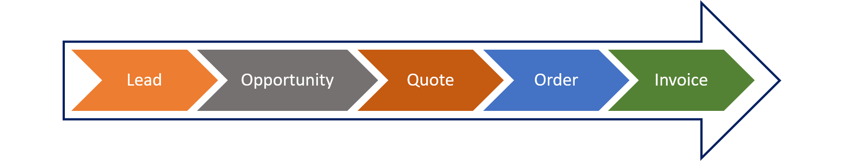

When prospects or customers express qualified interest in buying your products or services, they're considered opportunities.

An opportunity is a potential sale. Leads become opportunities after they're determined to be viable customers. Unlike lead records, which typically include only basic information, opportunity records provide more specific details, like potential revenue, timelines, and information about products or services.

Organizations use opportunities to forecast revenue.

Here are some common terms in Sales

|  |  |
| --- | --- |
| Term | Definition |
| Customer | A customer can be either an account or a contact. In business-to-business (B2B) scenarios, a customer is typically an account. In business-to-consumer (B2C) scenarios, a customer is typically a contact. For opportunities, a customer represents the potential customer that an opportunity applies to. |
| Account | An account represents a business or organization. An account can be set as the potential customer for an opportunity. |
| Contact | A contact represents a single individual. A contact can be set as the potential customer for an opportunity. |
| Activities | An activity is a type of table that offers tracking and scheduling options. Opportunities often have multiple activities for things like tasks, appointments, and phone calls. |
| Business process flow | A business process flow (BPF) is a type of automation in Microsoft Power Platform. A BPF appears on a table page and gives users guidance and a predictable action plan for gathering data. For opportunities, BPFs guide users through the steps and phases that are necessary to convert an opportunity to a sale. |
| Lead | Leads are used to determine someone's viability as a potential customer. Qualified leads are converted to opportunities. |
| Product catalog | A product catalog is a collection of records that facilitate management of products, price lists, discounts, and product families for sales transactions. Products from a product catalog can be added to opportunities as line items. |
| Quote | A quote is a formal offer for products or services that are proposed to a customer at specific prices and related payment terms. Quotes can be created from opportunity records. |
| Order | An order is a confirmed request for the delivery of goods and services at specified terms. Alternatively, it's a quotation that has been accepted by a customer. |
| Invoice | An invoice is an order or a record of a sale that has been billed to the customer. It includes details about the products or services that were bought. |

Here is the sample of Sales Process

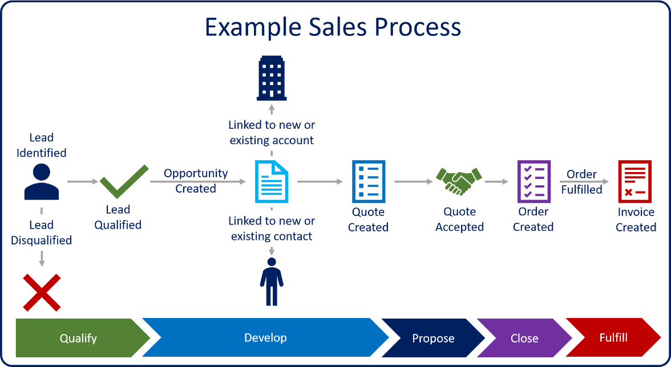

In the preceding image, a lead has contacted your organization about products and services. An account executive has reached out to the lead to gather more information about him or her, and to determine whether the lead and your organization will be a good fit for each other.

1. If the account executive determines that there's a good fit, the lead is qualified as an opportunity.
   * If the lead is an existing customer, a new opportunity is created and associated with an existing account and/or contact record.
   * If the lead is a new customer, new account, contact, and opportunity records are created.

Alternatively, if the account executive determines that there isn't a good fit, the lead is disqualified, and the sales process ends.

1. Details are added to the opportunity. These details include the products and services that the lead is interested in, the estimated revenue, and timelines.
2. A quote is added to the opportunity. The quote represents the formal proposal to the customer.
3. When the customer agrees to the quote, an order is generated. The quote and opportunity that are associated with the order are closed.
4. After the order is fulfilled, an invoice is generated to bill the customer.

Now, we want to create opportunity and then generate invoices

#### Task 1: Create opportunity from existing Lead

1. Go to **Sales Hub**

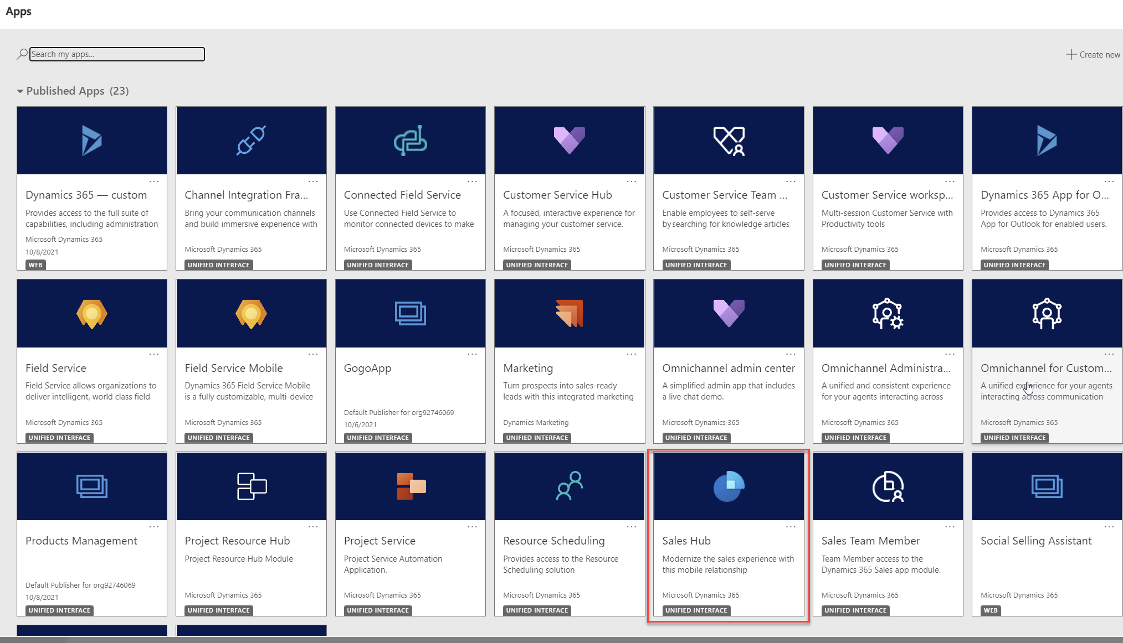

1. Go to **Leads** and choose any lead

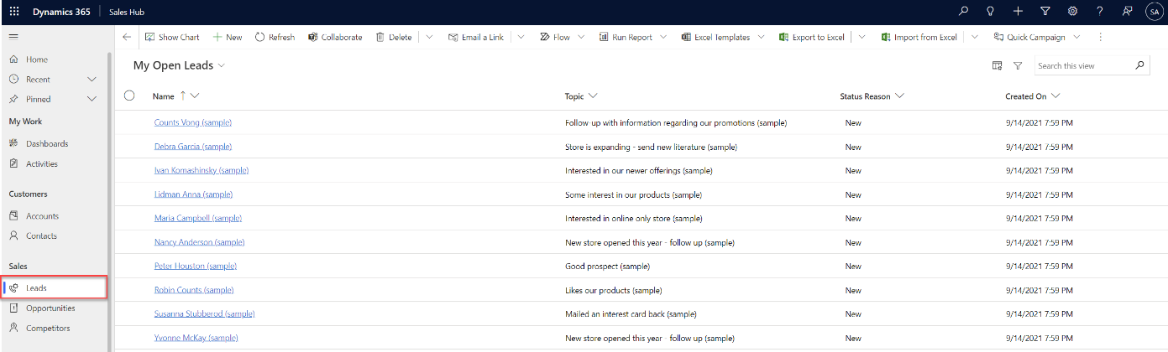

1. Click **Qualify** at the top command bar.

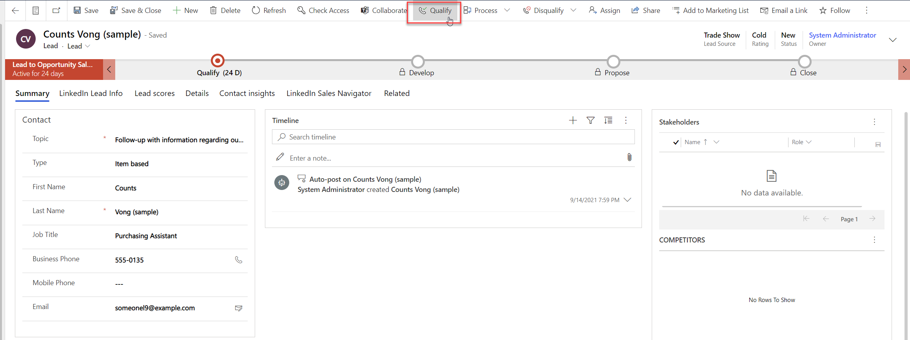

1. If you are prompted dialog due to existing Account/Contact, you may just Ignore and Save in this exercise, while in the real scenario you may need to link to existing records instead of creating new duplicated one.

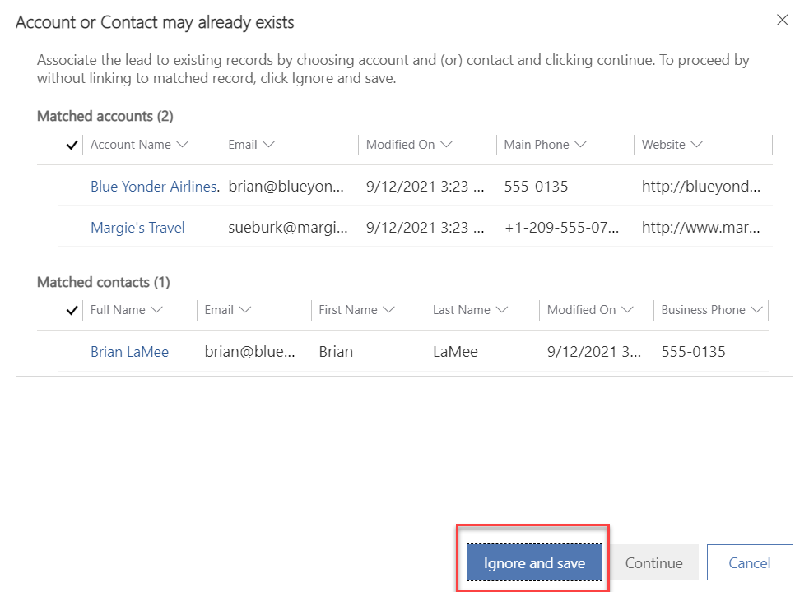

1. New **Opportunity** form will be opened, and you have created new opportunity generated from the Lead you have chosen with the data is also being flown over to this opportunity,

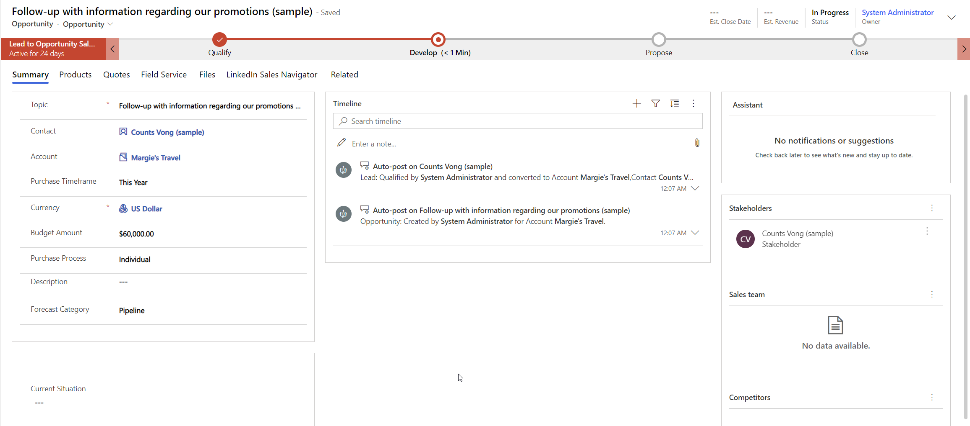

1. In the Opportunity form, you can also add more detailed information and even add people into Sales Team

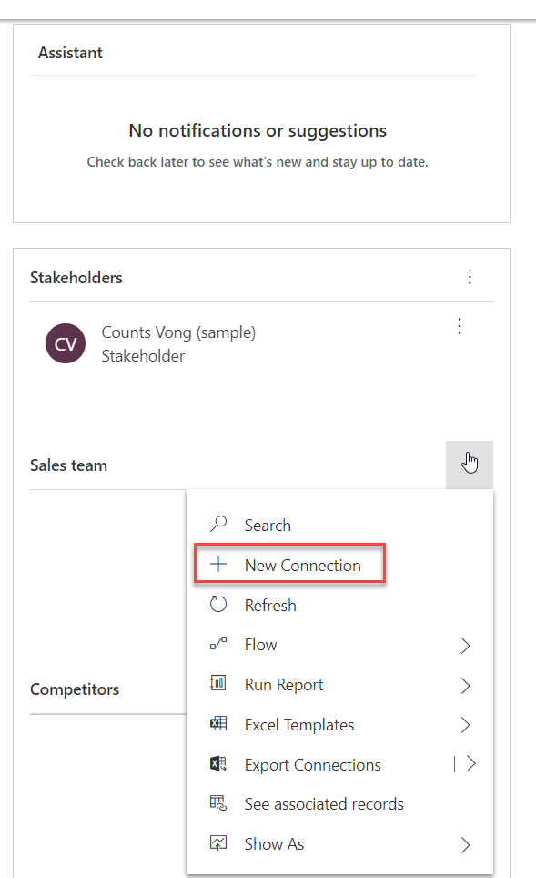

When you create opportunities, it's important that you define as much information as possible about the current situation and what will be required to move forward. This information can help determine which sales process should be used, based on the type, size, and timeline of the opportunity. This information can also help determine which sales resources should be assigned to the record to give your organization the best chance of winning the deal.

Here's a description of some of the main information that can be included for an opportunity.

|  |  |
| --- | --- |
| DEFINING OPPORTUNITY DETAILS | |
| Stakeholders | Contacts in Dynamics 365 who have a vested interest in the opportunity. Stakeholders can include project managers, board members, lawyers, and sponsors. |
| Sales team | Internal team members who will be involved in converting the opportunity to a sale. |
| Competitors | Any external competitors that you might be competing against for the deal. |
| Pricing information | The price lists that will be used and the calculation method that will be used to estimate the value of the opportunity. |
| Opportunity line items | The specific products and services that are being suggested to the customer as part of the solution. |

[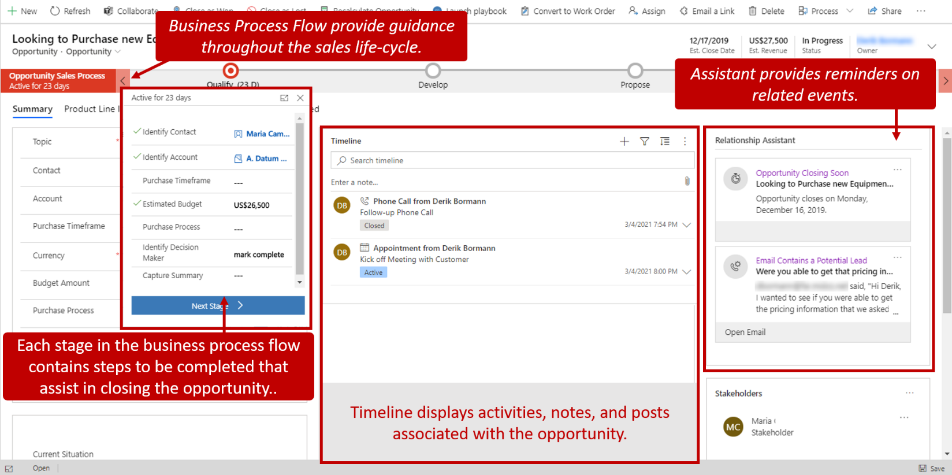](https://docs.microsoft.com/en-us/learn/modules/manage-opportunities-dynamics-365-sales/media/opportunity-flow-ssm.png#lightbox)

#### Task 2: Add products into opportunity

1. Still in the Opportunity form, go to **Products** tab

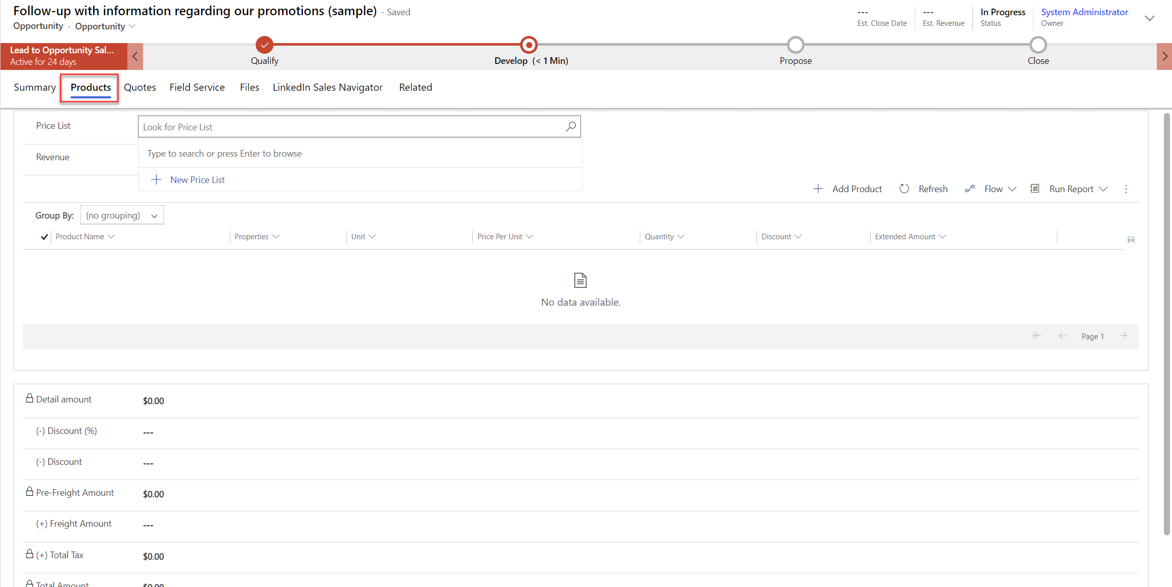

1. Choose **Price List**

One of the main advantages of using Microsoft Dynamics 365 Sales to manage opportunities is that product and pricing information can be defined in the opportunity record itself. Because quotes, orders, and invoices can pull product and pricing information directly from opportunities, definition at the opportunity level helps make forecasting more accurate.

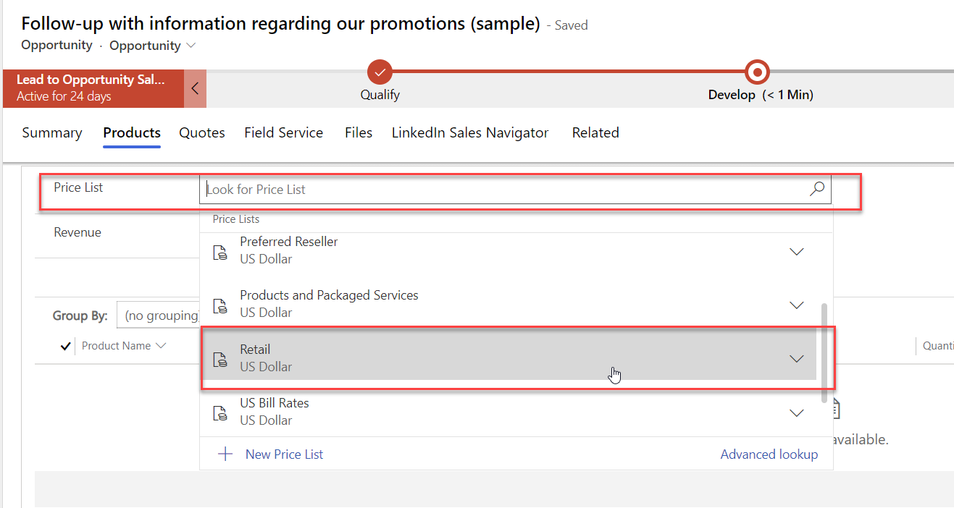

1. Set revenue to **System Calculated**



1. Add product and fill in the information, choose the products you want to offer and include in this opportunity.

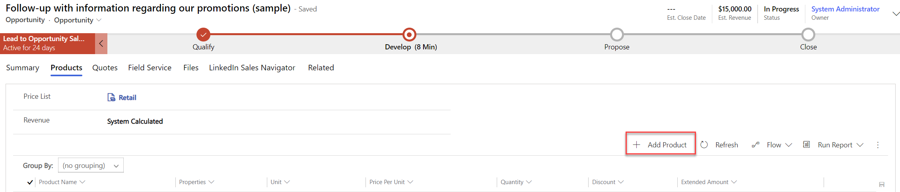

1. Select product as Existing product, choose Unit, and then choose Existing Product.

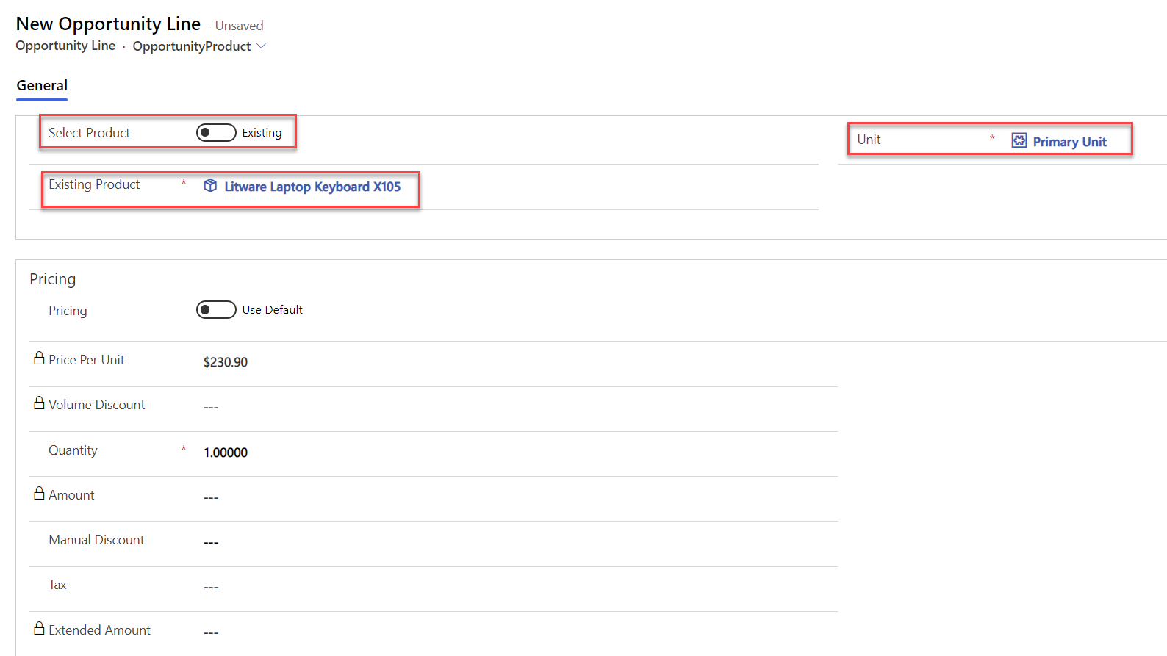

You notice that you can only choose Existing Product which is part of the **Retail** Price List and you can see the Price Per Unit is automatically filled in.

1. Key in few Opportunity Products

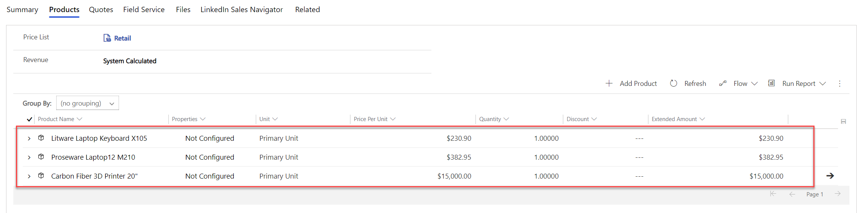

With this you can offer multiple products into the opportunity through out of the box opportunity form, however it is totally possible to customize the system to adjust to the requirement, for example customize the subgrid to allow showing images, etc.

#### Task 3: Edit Opportunity Product using

1. Go to the subgrid in the form
2. Then, just click row in the Quantity column and it will activate the editable subgrid, you can change the Quantity without opening new form.

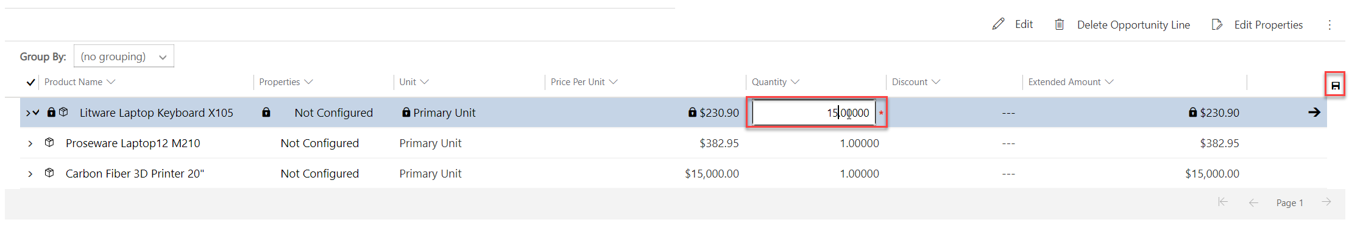

1. Change the quantity and then click Save

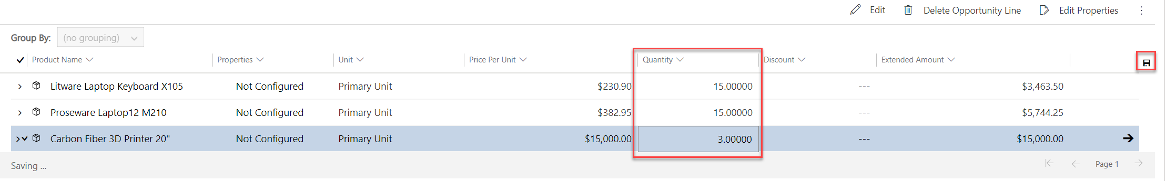

#### Task 4: Advance Opportunity stage

If you notice, opportunity created from Lead has passed Qualify stage and then now in Develop stage.

Now, we want to advance further.

Below is the example of Lead to Opportunity Business Process Flow.

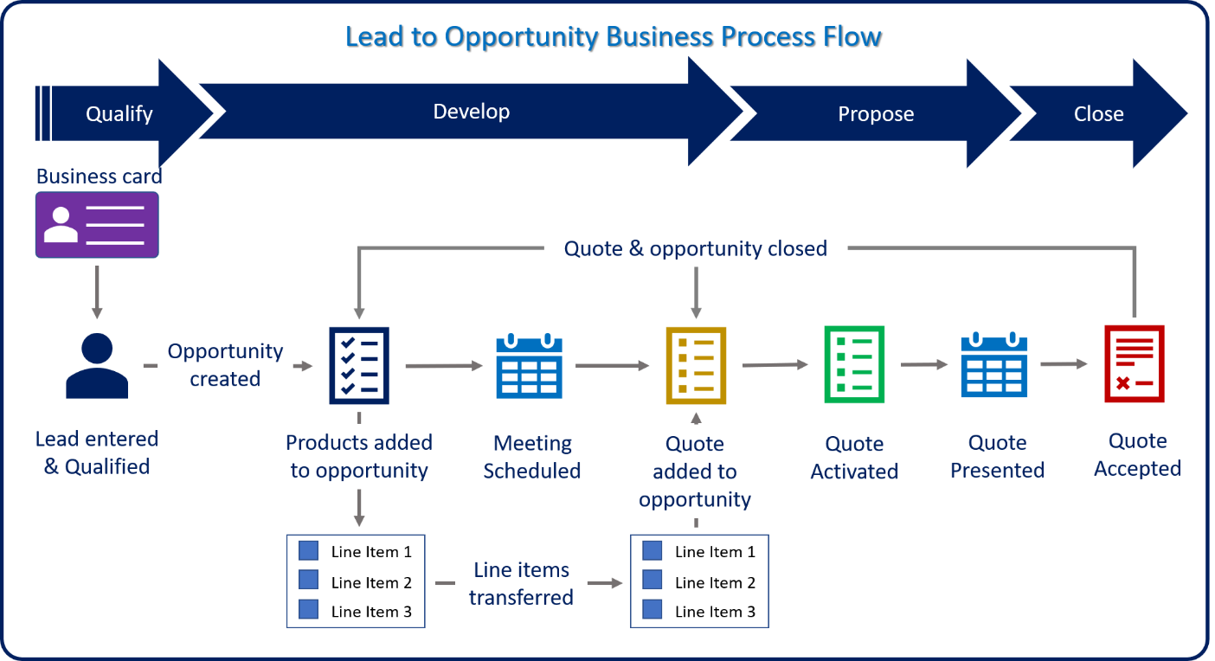

1. Click **Develop** and fill information, then click **Next Stage**

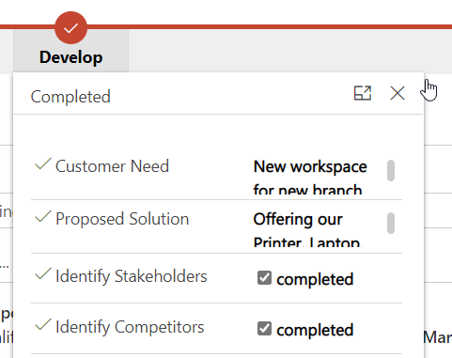

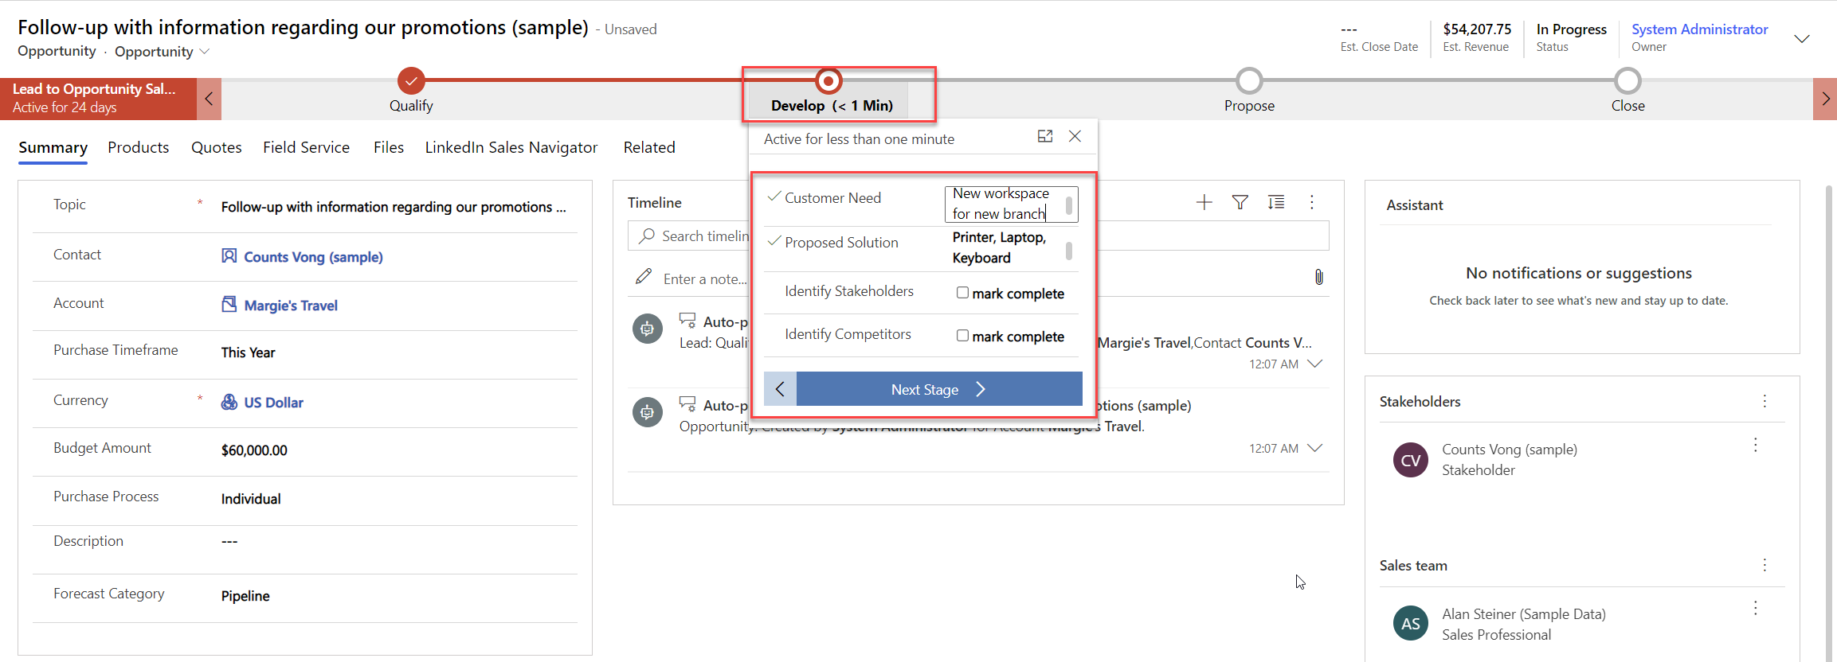

1. In **Propose** stage, you can start proposing your solution or offering to your potential customer, you can create Quote.

#### Task 5: Create New Quote

1. Go to **Quotes** and select **+ New Quote**

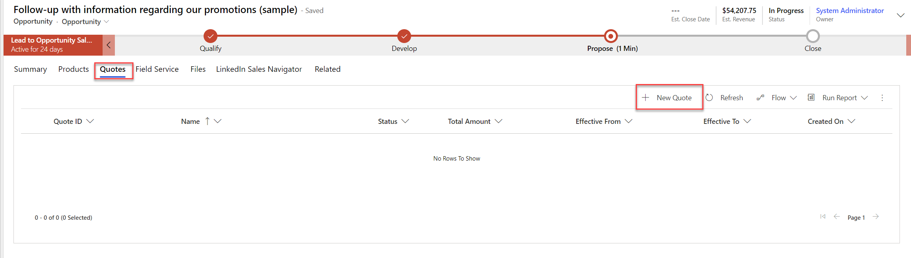

1. New Quote form will appear and you can see all the details are automatically filled in based on opportunity data

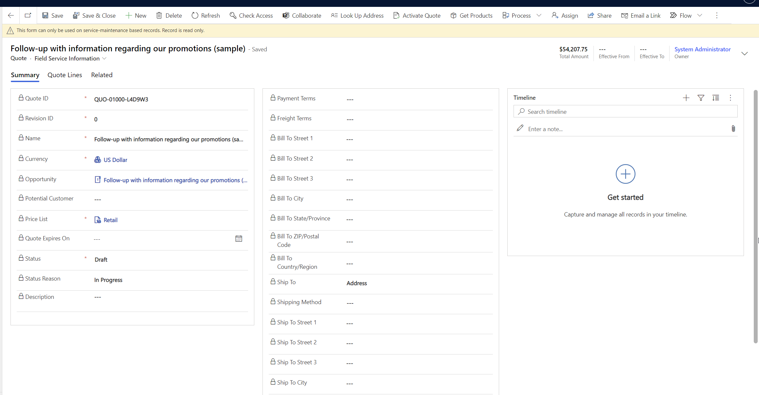

It does include the **Quote Lines** as well which comes from Opportunity Product

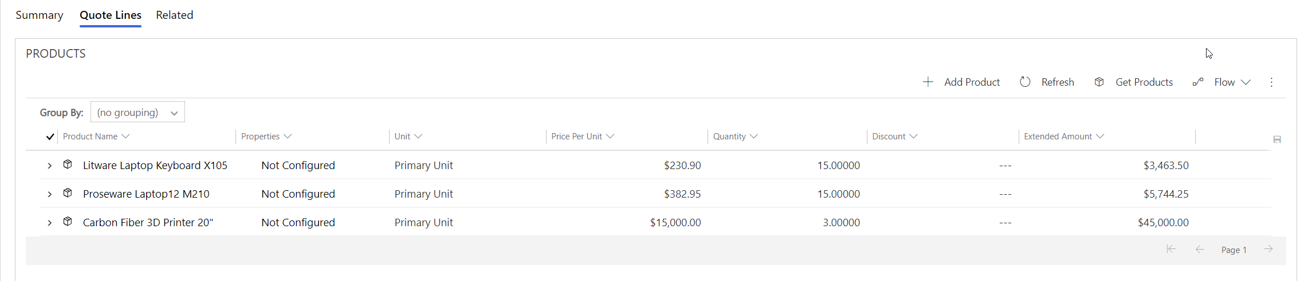

1. **Activate** the Quote

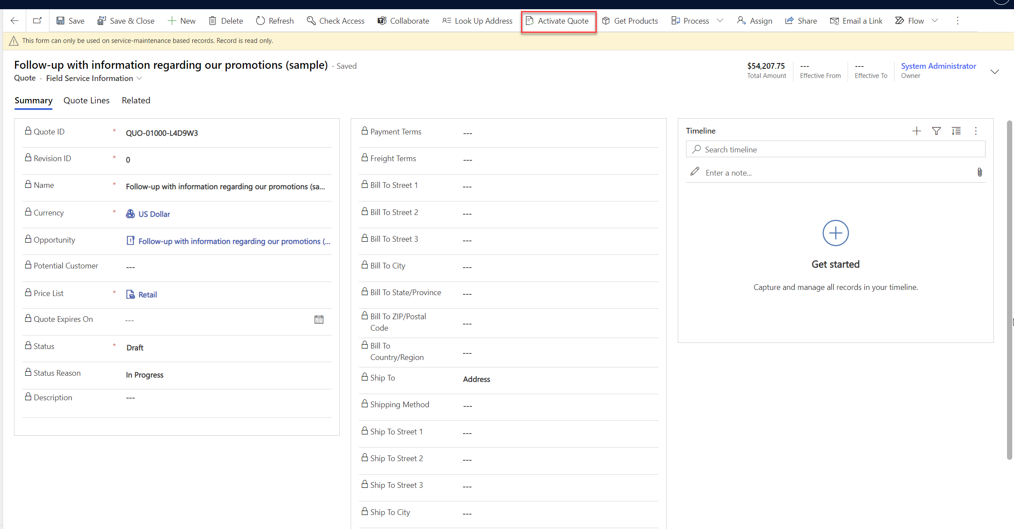

The quote now is in Active status

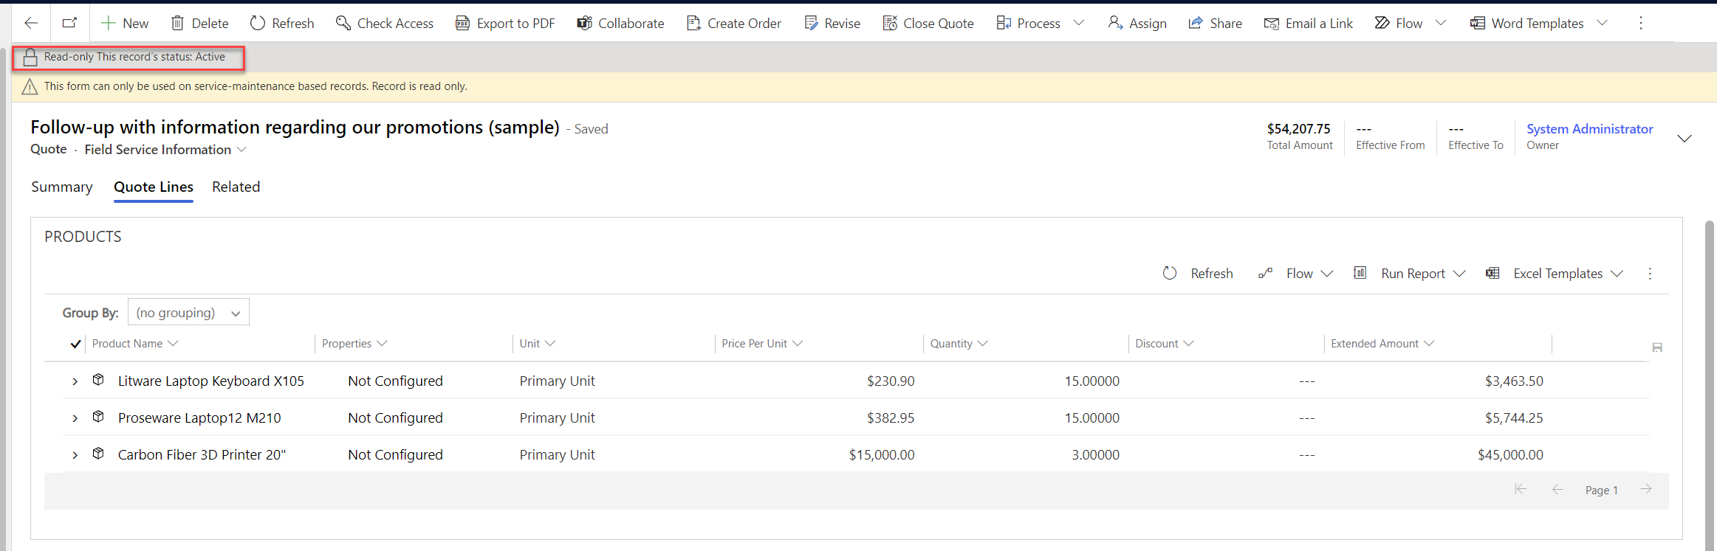

#### Task 6: Revise Quote

You revise the quote by adding more products and discount as customer agrees to buy more if you give discount.

1. Go to **Quote Lines**, then select **+ Add Product**

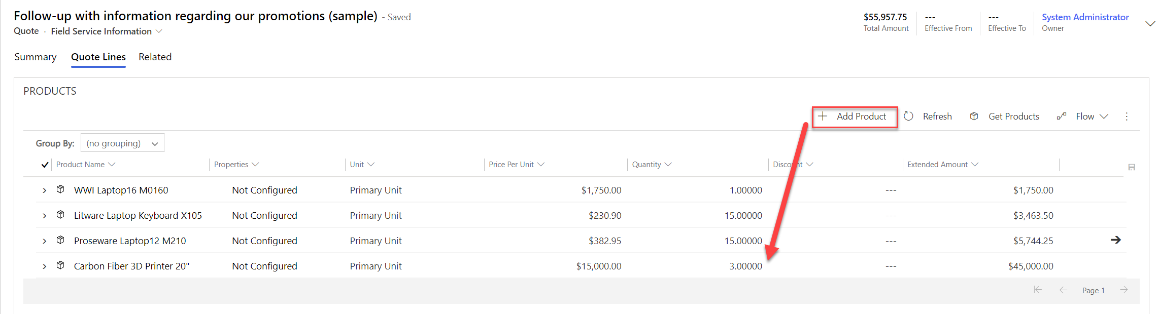

1. Edit to add manual discount

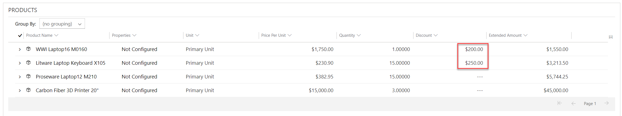

1. Now, you are ready to print the Quote and give to Customer

#### Task 7: Generate Quote Document for Customer

1. At the top right, select vertical **…** icon and then choose **Word Templates**

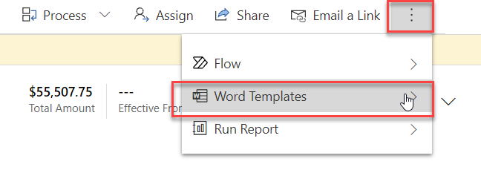

1. Click the right arrow

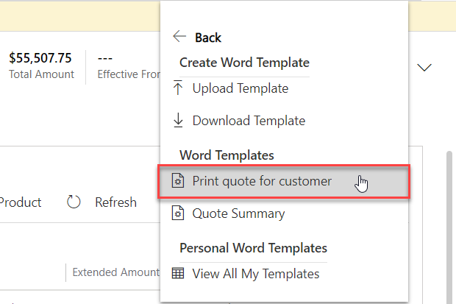

You can choose to upload new template or download existing template, in this case, we will just use existing template, you can select **Print quote for customer**, it will then download the file for you.

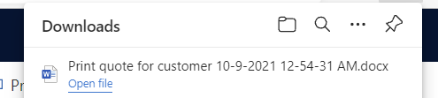

1. Open the file and you can get the file in word document as per your Word template with all the information, including four offered products, it is very useful feature.

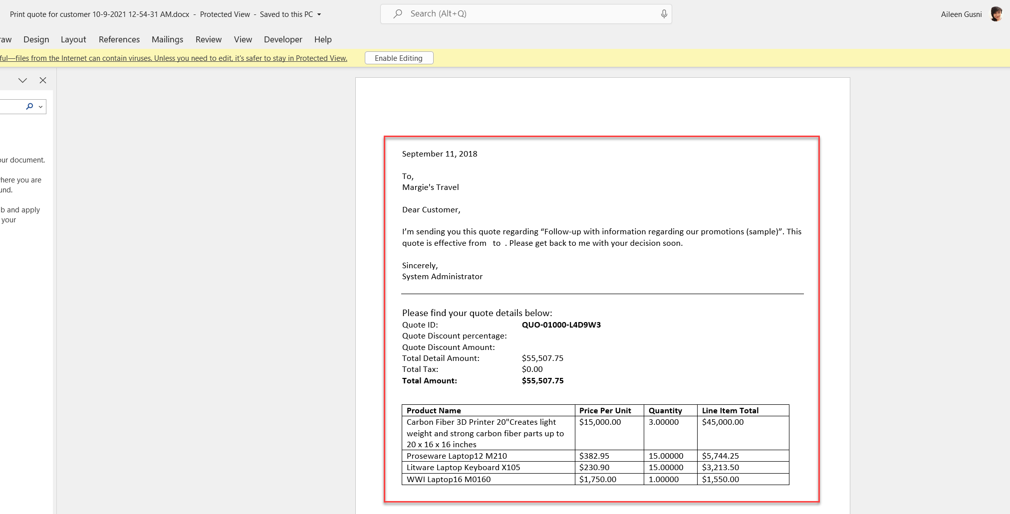

1. You can **Activate** the Quote again
2. Go back to the **Opportunity** tick all the checkboxes in the **Propose** stage, assuming you are as sales person has done your things such as Identify Sales Team, Develop Proposal, and Complete Internal Review.

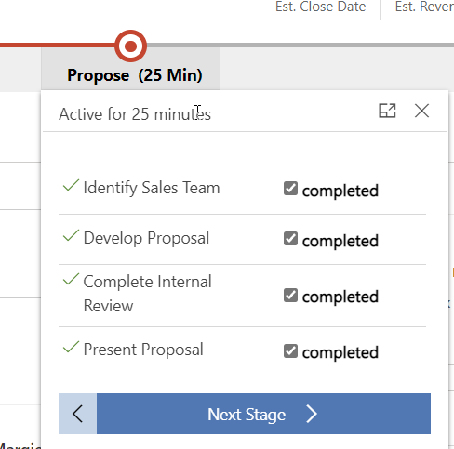

1. You can go to **Quote** tab in the Opportunity form and see two quotes are there, you can also see that this process has been active for 24 days.

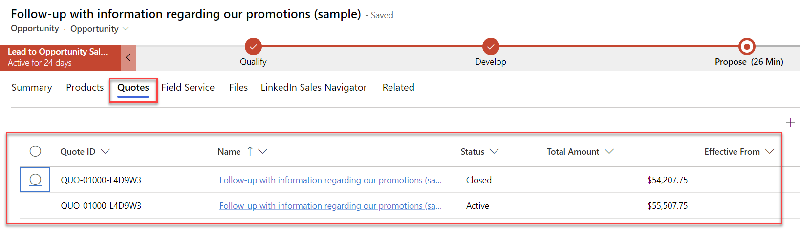

#### Task 8: Create Order and Close Opportunity as Won

In this task, with all the teamwork effort, you will qualify opportunity as Won, congratulations!

1. Now, go to the **Quote** again
2. You can **Create Order** after activating the revised quote

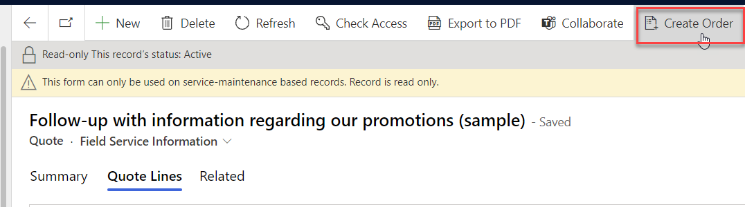

1. A new pop up will appear and you can just click **OK**

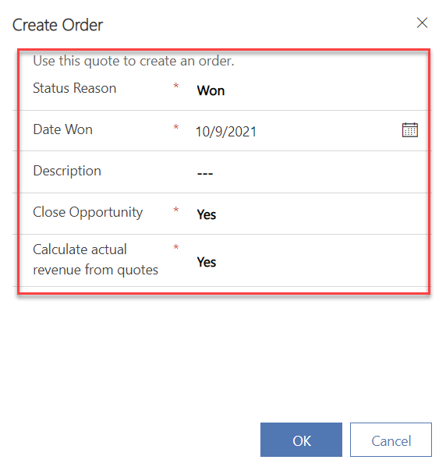

1. A new Order record has been created and your opportunity has been officially closed as Won!

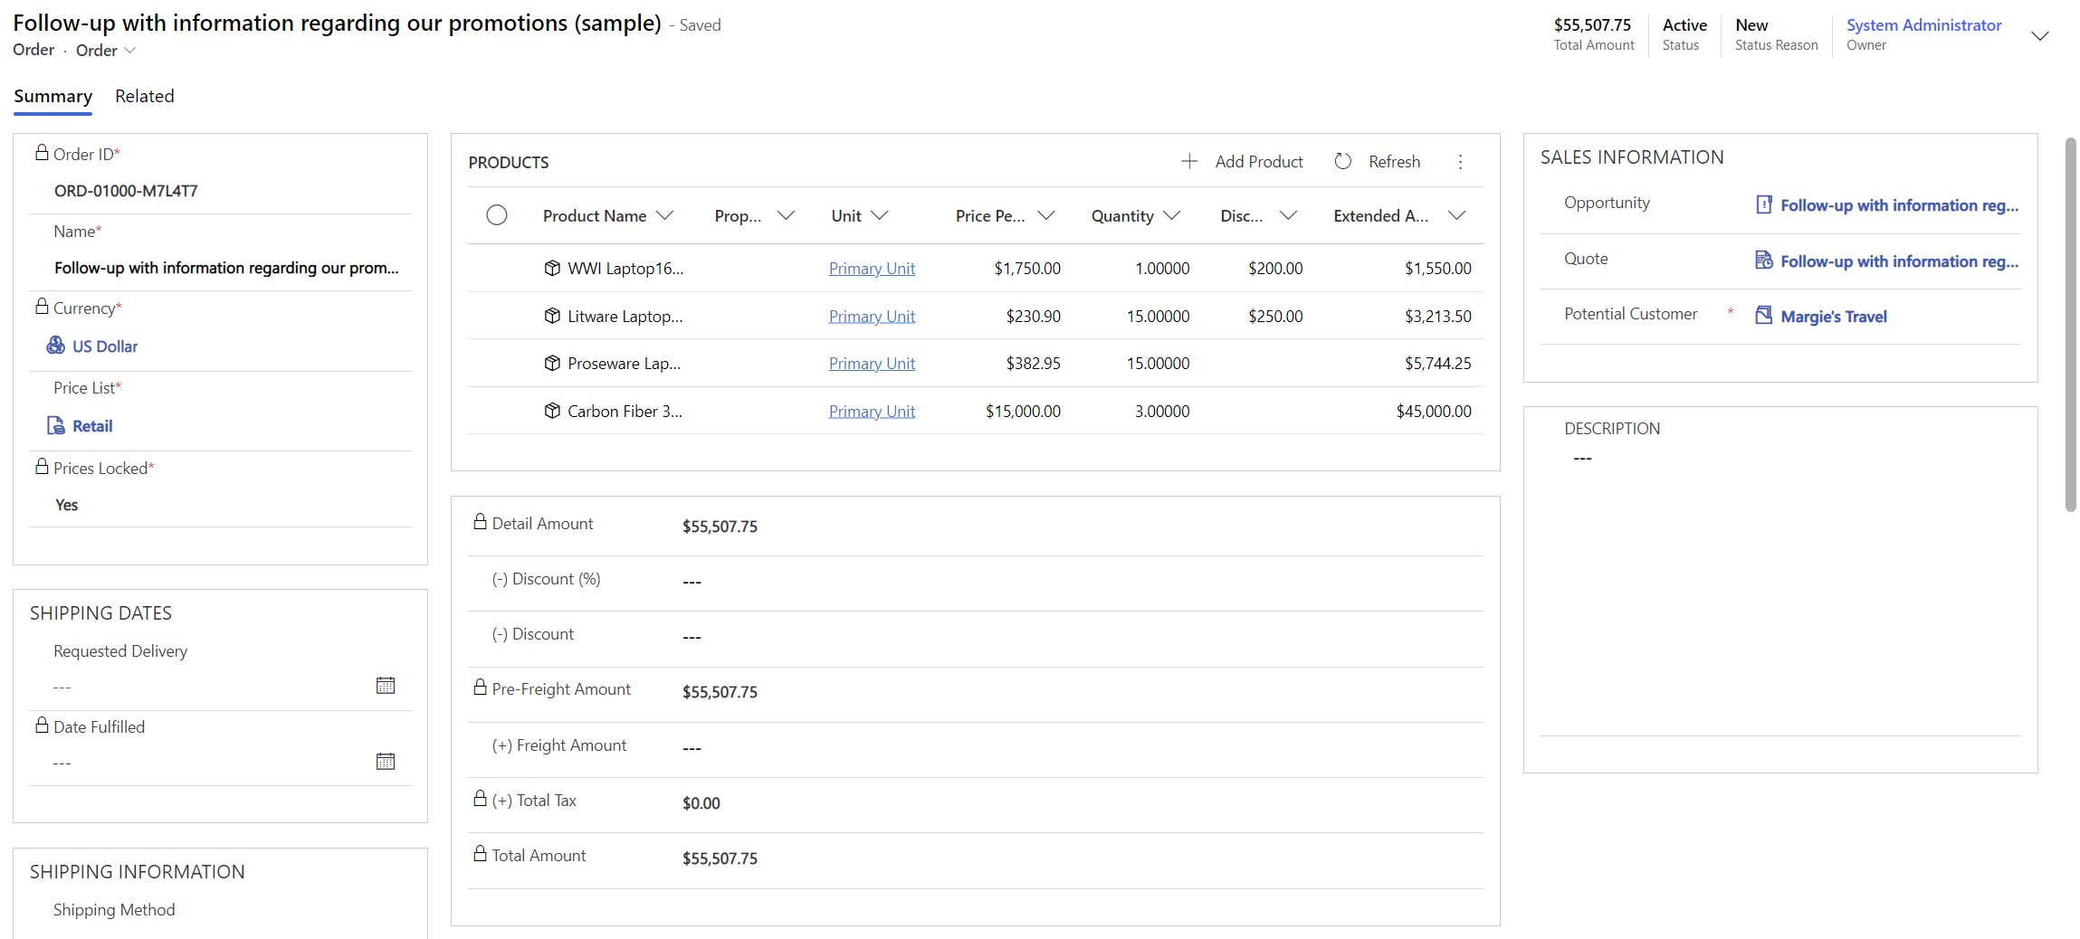

Now, from here you can create invoice and fulfill the order as well or you can customize it to grab the status and sync with your ERP system.

There are many buttons you can select depending on the real scenario, just with a hope never click **Cancel Order**.



From the order, if you go back to the original opportunity

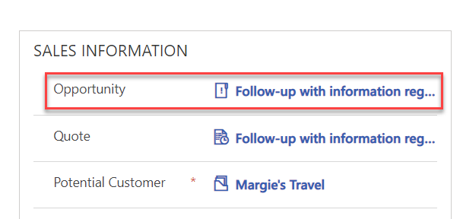

You will see that your Opportunity has been closed as Won.

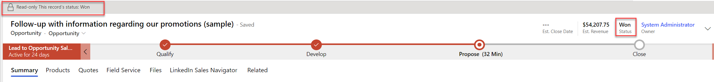

#### Task 9: View Sales Dashboard

Your newly Won Opportunity should be included in the Dashboard

1. Go to **Dashboard**

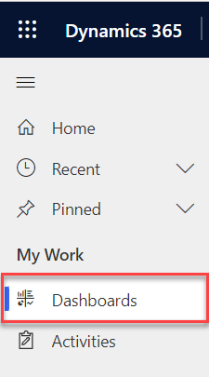

1. Go to **Sales Activity Social Dashboard**

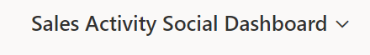

1. You will see the Maggie Travel there in one of the chart

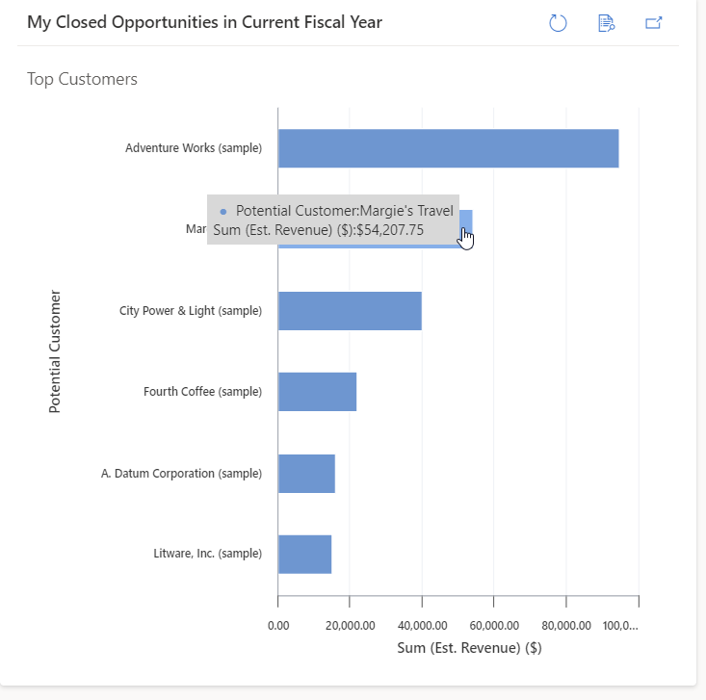

## Exercise 2: Install and Enable LinkedIn Sales Navigator

First, you need to understand the usage and value proposition of the Microsoft Relationship Sales Solution (MRSs)

Microsoft combines the tools of Microsoft Dynamics 365 Sales, Power BI apps, and LinkedIn Sales Navigator for you and your customers’ selling success.

MRSs (Microsoft Relationship Sales Solution) is a discounted SKU that combines Microsoft Dynamics 365 Sales and LinkedIn Sales Navigator which:

* Displays LinkedIn information on existing leads and accounts in Dynamics 365 through the Sales Navigator widget.
* Provides a daily sync between Sales Navigator and Dynamics 365, so that leads, contacts, and accounts already present in Dynamics are visible within Sales Navigator.
* Writes select Sales Navigator activities to Dynamics 365 with a single click.

Capitalize on Sales Navigator and Dynamics 365 for your relationship selling success and engaging your prospects and clients. Maximize sales productivity via MRSs (Dynamics 365 and LinkedIn Sales Navigator). The sync of these two solutions is the price and feature differentiator you can offer your customers. The MRSs SKU offering - a discounted rate on Sales Navigator synced with the CRM – you have an exciting and unique offer for your customers – the only offering of its kind in the industry.

The LinkedIn for Microsoft Dynamics CRM application allows you to view LinkedIn information about leads, contacts, accounts, and opportunities directly in the Dynamics 365 apps. The solution brings together disparate data across Dynamics, Microsoft 365, and Sales Navigator. With unified relationship data, sellers can get a view of relationships and deliver the authentic and personalized engagement today’s buyer’s demand.

**Pain points addressed**

The primary pain points addressed include the utilization of solution(s), enhanced features, improved insights, elevated data hygiene, and measurable results. Sellers today are not finding all the key players in a deal, are perceived as not adding value to the buyers, and struggle to stay productive while juggling multiple relationships.

Benefits of MRSs

**The benefit of utilizing MRSs** solves for multiple challenges sales professionals struggle with each day. MRSs enables sales professionals to build relationships with the right people, offer insights and recommendations, and engage at scale via with their prospects and customers. An important element of this is providing the ability to improve their workflow efficiency and productivity and effectiveness. Currently sales professionals waste 14 hours per week on administrative activities such as updating a CRM. (Source: Sirius Decisions, 2018)

#### Task 1: Install LinkedIn Sales Navigator through App Settings

There are few ways to install and enable LinkedIn Sales Navigator, in this class we will learn installing it through App Settings. Refer to <https://docs.microsoft.com/en-us/dynamics365/linkedin/install-sales-navigator> to see another way.

1. Sign in to your Sales Hub app.

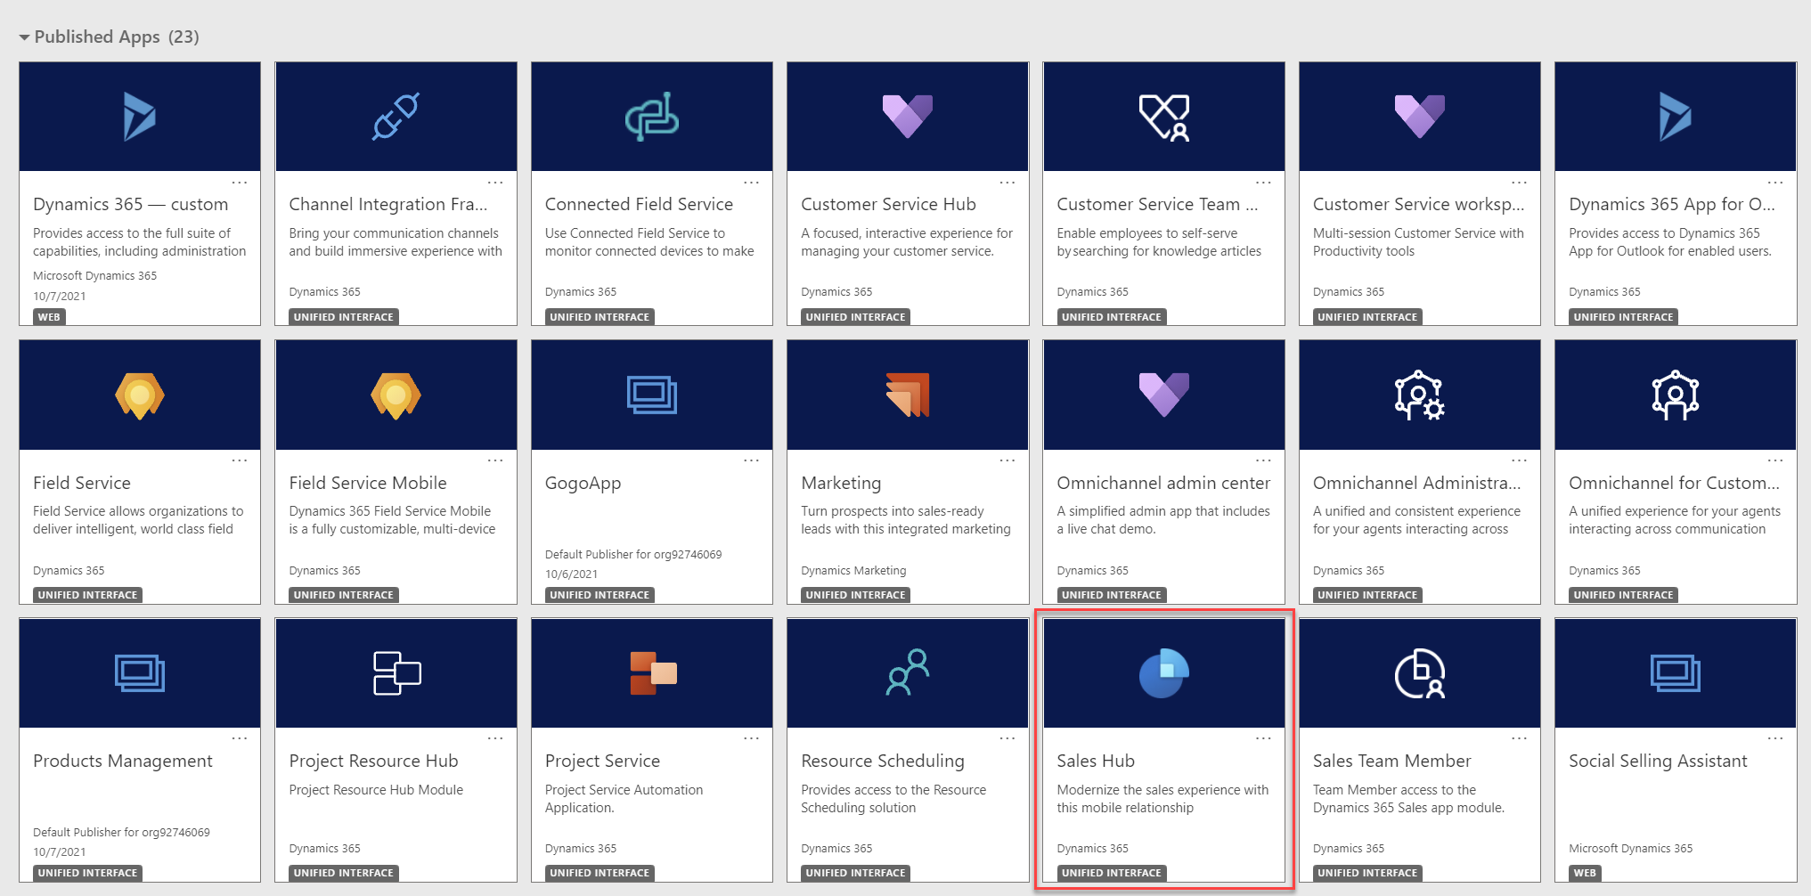

In the site map, at the lower-left, select the Change area icon (2 chevron icons) , and then select **App Settings**.

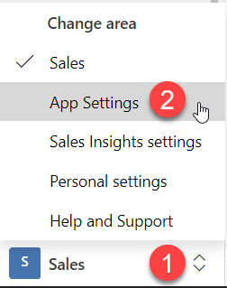

1. Under **General Settings**, select **LinkedIn integration**, then **Enable LinkedIn integration**.

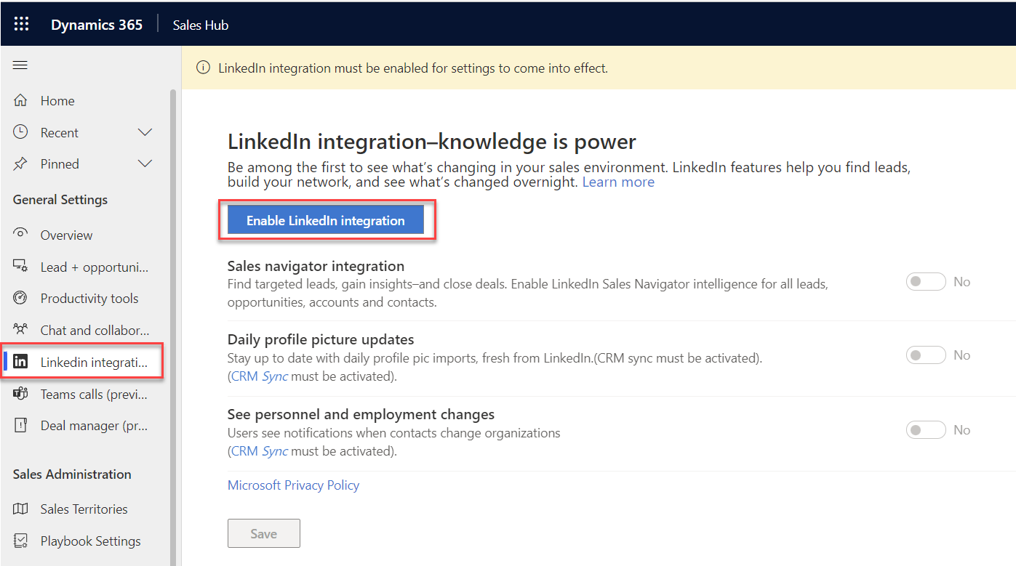

1. It will then bring you to the new **Installation**  page (Note: if you are asked to login, just please sign in your given credential) then **Continue**

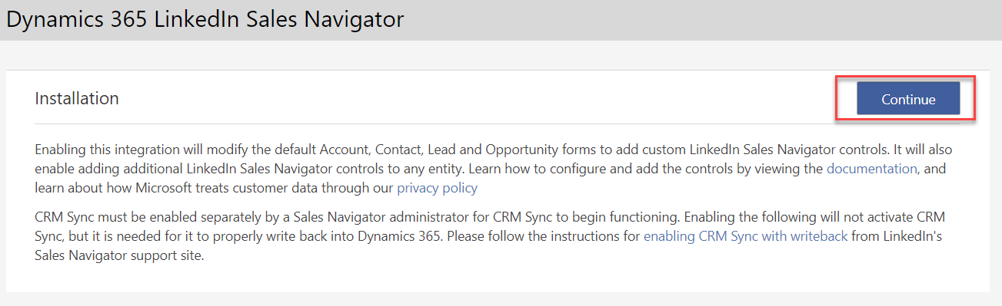

1. On the **Installation** tab, select **Continue** to install the required solutions.

**Note**

The installation may take few minutes to complete.

1. When the installation is completed, select **Go to Configuration**

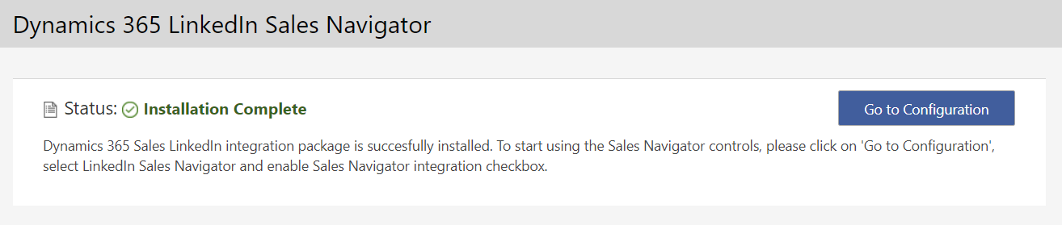

1. You can also verify that the installation is complete by following the steps below.

**Validate the installation**

1. In your app, select **Settings** and then select **Advanced Settings**.

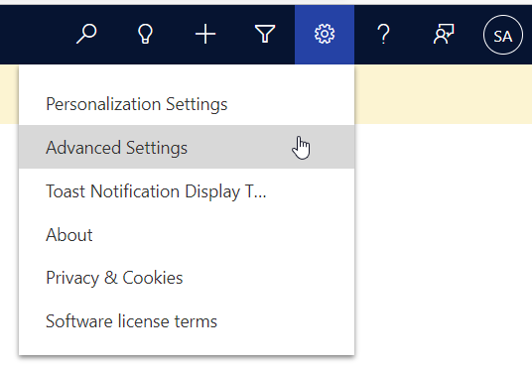

1. Go to **Settings** > **Customizations** > **Solutions**.
2. Verify that the following solutions are installed in your organization.
   * LinkedInSalesNavigatorControlsForUnifiedClient
   * LinkedIn
   * msdyn_LinkedInSalesNavigatorAnchor

#### Task 2: Enable LinkedIn Sales Navigator

When enabled, the Sales Navigator controls will appear on Account, Contact, Lead, and Opportunity pages by default. You can also customize other forms and entities to show Sales Navigator controls. Use one of the following procedures to enable default controls for LinkedIn Sales Navigator content.

1. Now, you can enable the LinkedIn Sales Navigator you installed in Task 2

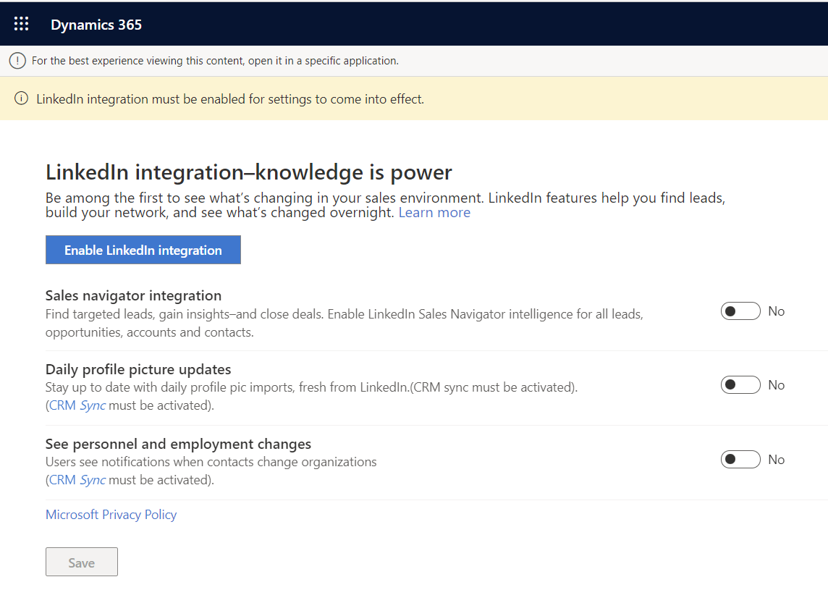











1. Now, enable all 3 options:

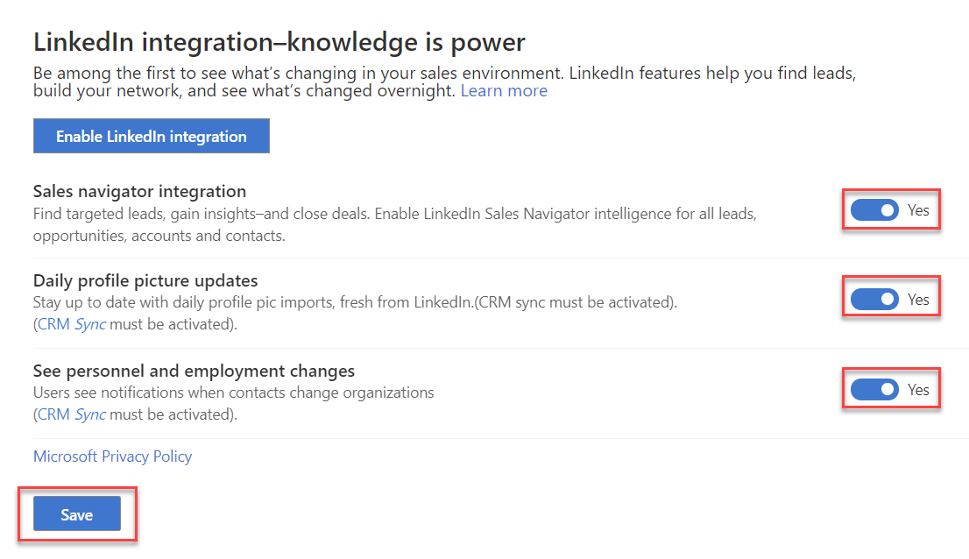

1. Then click **Save**
2. Now,you can see a new tab is added, **Linkedin Sales Navigator** in few core entities, such as Account, Contact, lead, and Opportunity.

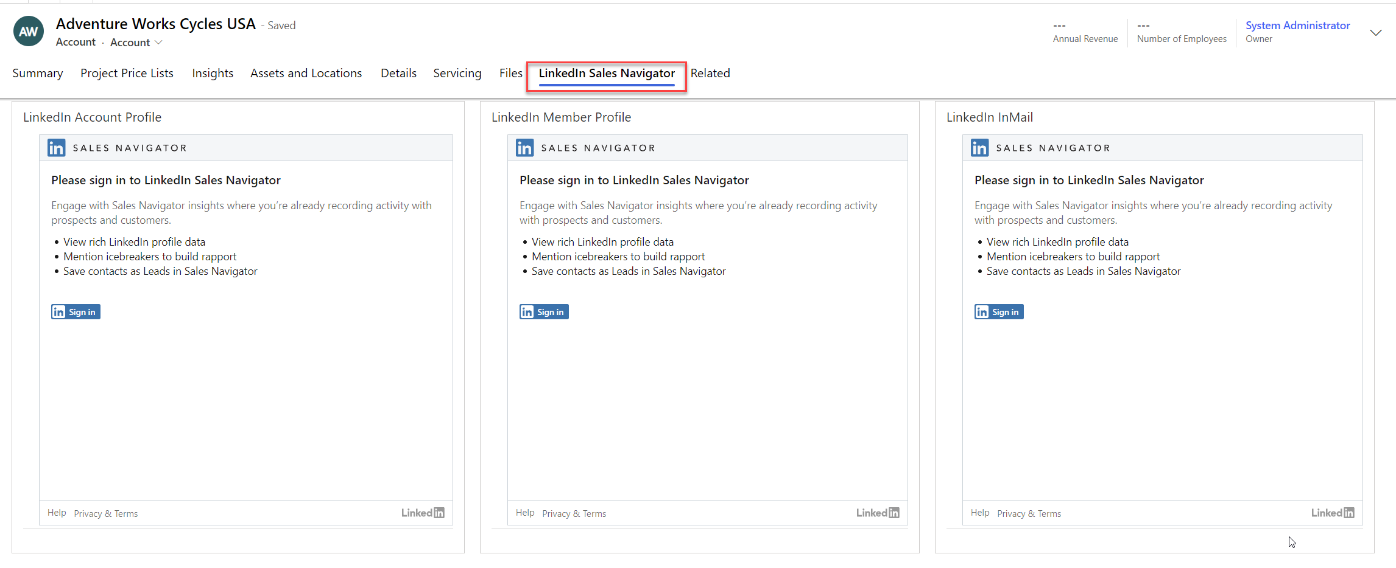

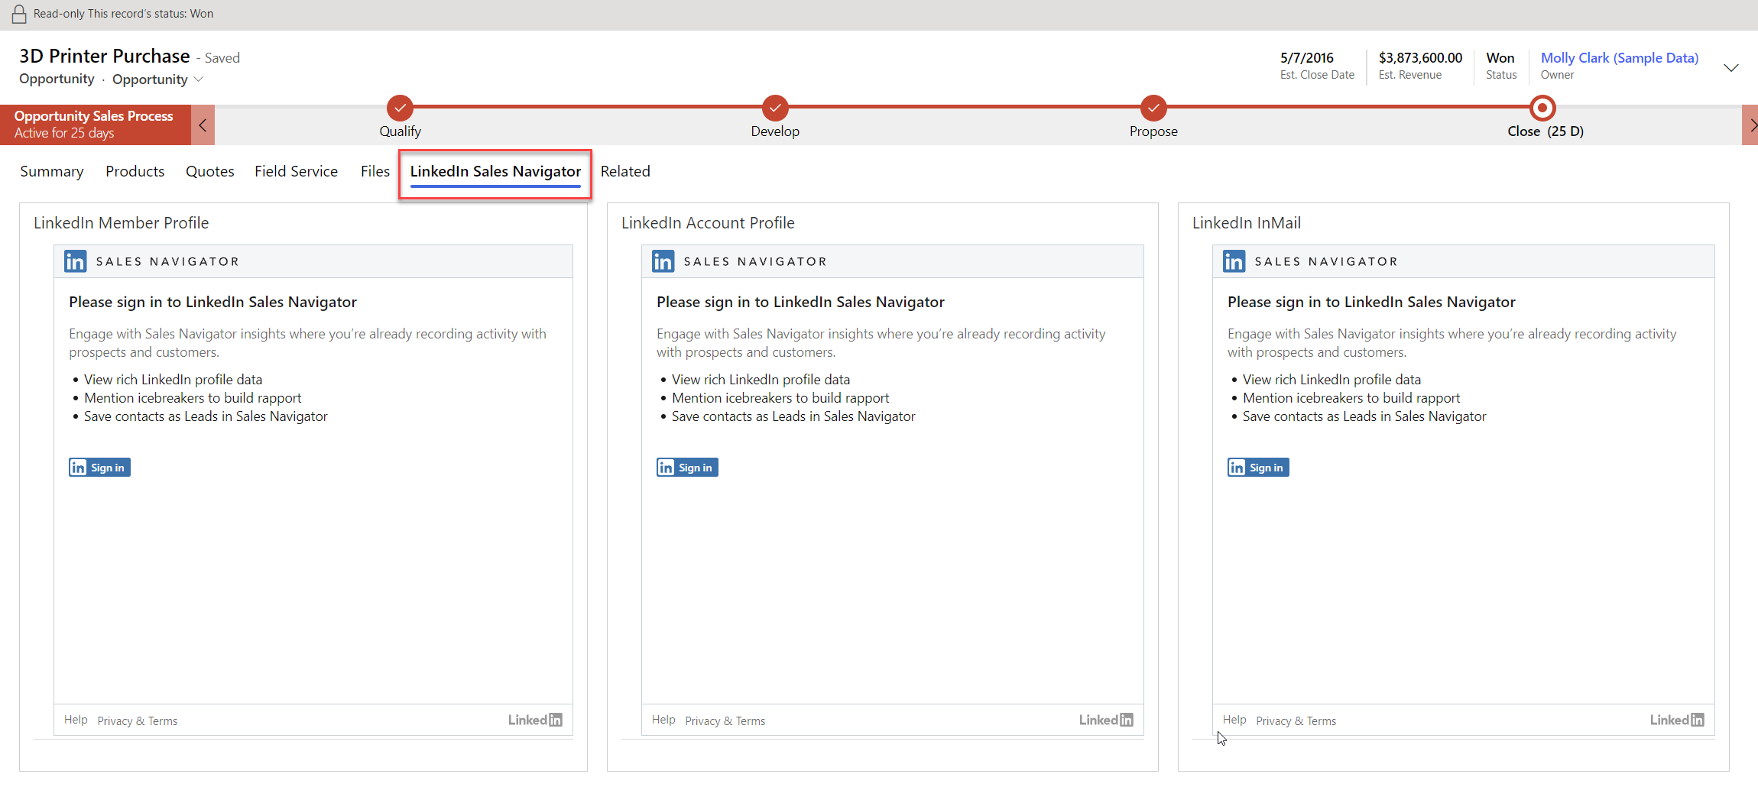

#### Task 3: Sign in to Sales Navigator

1. From any form that has LinkedIn Sales Navigator, please **Sign In**.

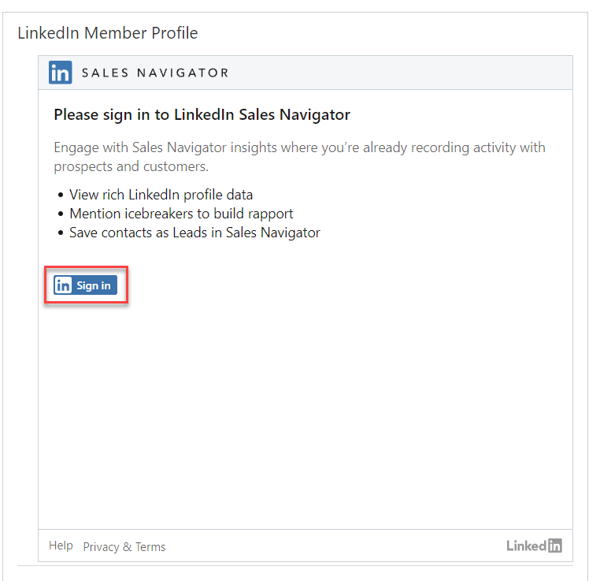

1. Sign in to your LinkedIn Account

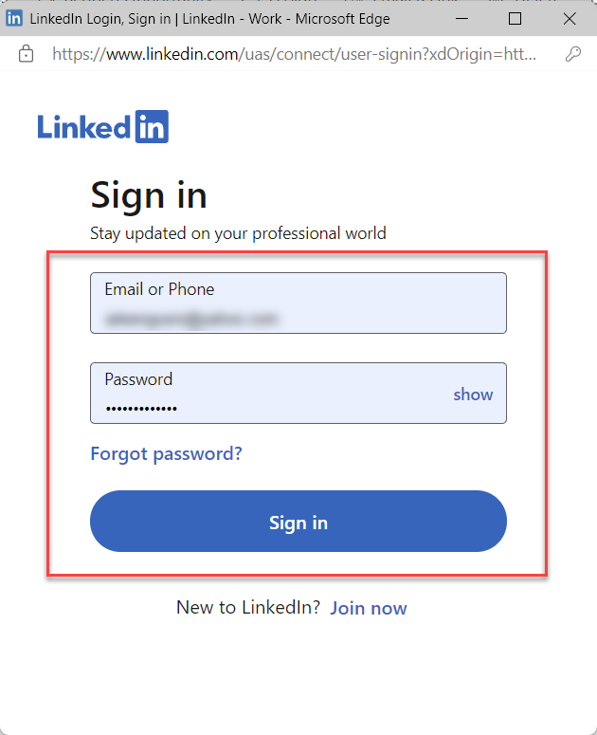

Just to note here, It is recommended to use an integration user rather than a personal or generic admin account since personal admin credentials can be revoked when that user leaves the company or their role changes. Using an Integration User can prevent accidental sync disconnection due to permission changes. If you choose not to use an Integration User on initial setup and desire to change after setup, you can always un-sync and then re-sync with the Integration User as the Microsoft Dynamics 365 Sales Admin.

1. After you sign in, if you don’t have the LinkedIn Sales Navigator subscription as pre-requisites then you will see this message

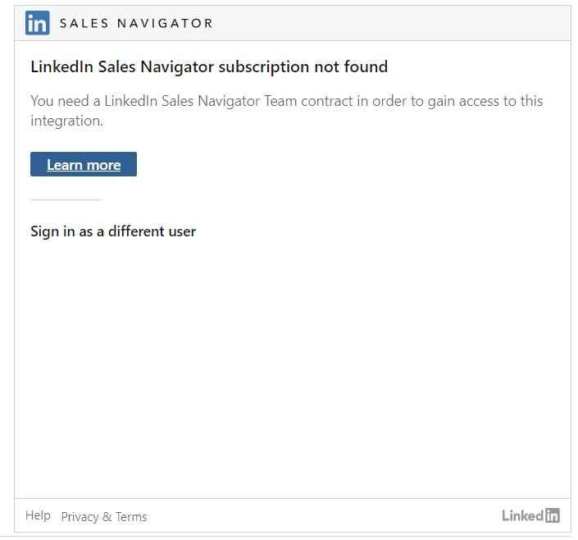

You can try to start the trial to explore the feature.

#### Task 4: Explore LinkedIn Sales Navigator (Optional)

You can sign up for trial or just try follow this guidance to know more about LinkedIn Sales Navigator

1. After you signed in and you will be able to see the LinkedIn connection

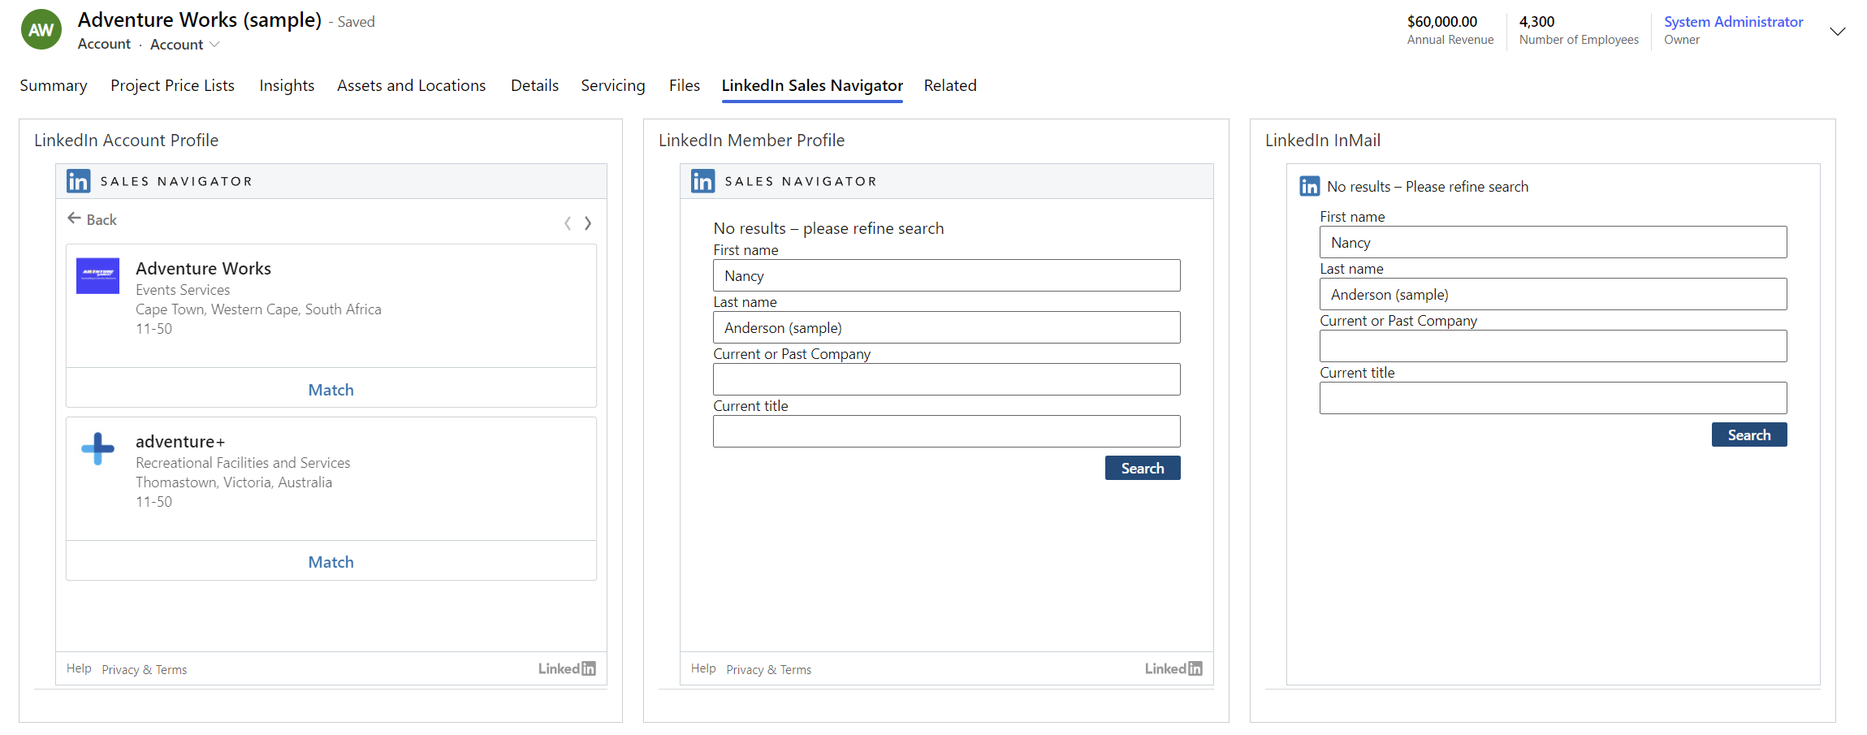

1. Then, to test it out, you can create new Account and rename existing Contact that can represent accurate data.

You can create a new Account with name: **Microsoft** or rename it if you have already had the sample data

For example:

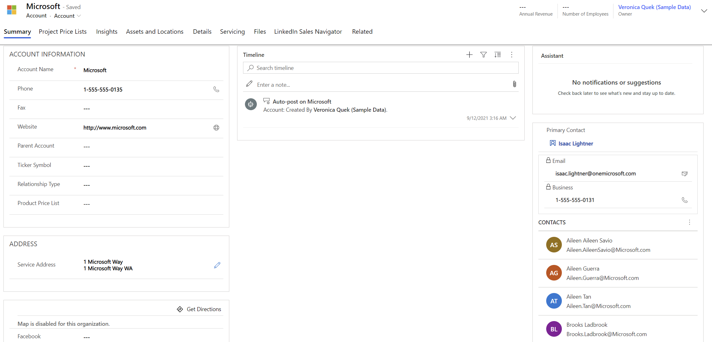

You will be able to see the Sales Navigator Account Profile of Microsoft, then select **Save in Sales Navigator**

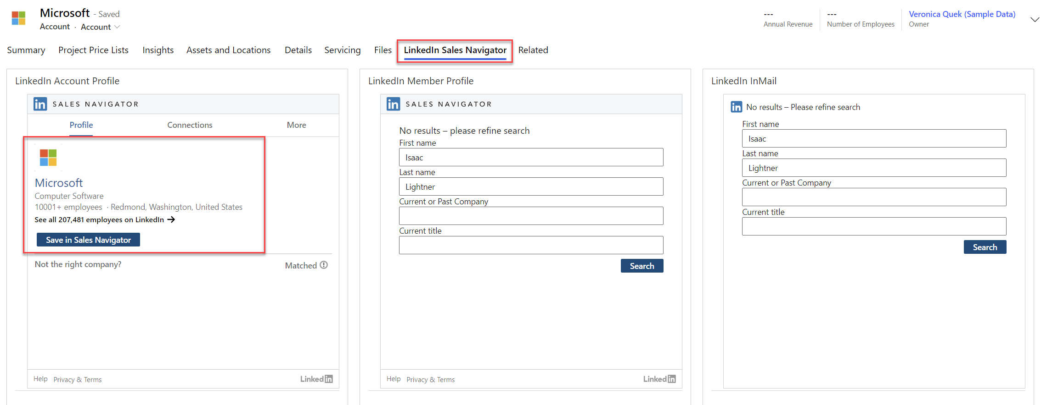

For the Member Profile, you can change the first name and last name to the person that you know from Microsoft.

For example:

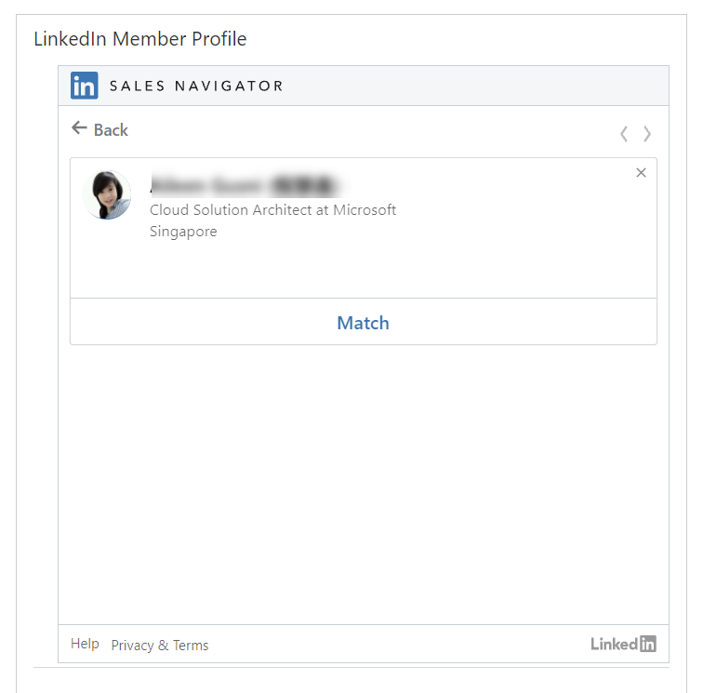

1. You can rename a new Contact and make it as related to **Microsoft**, you can use Contact from the Segment that you have from Lab 1.

You can also use your company name in the Account form and then match in through LinkedIn Sales Navigator and also for Contact record you can use your own name, for example: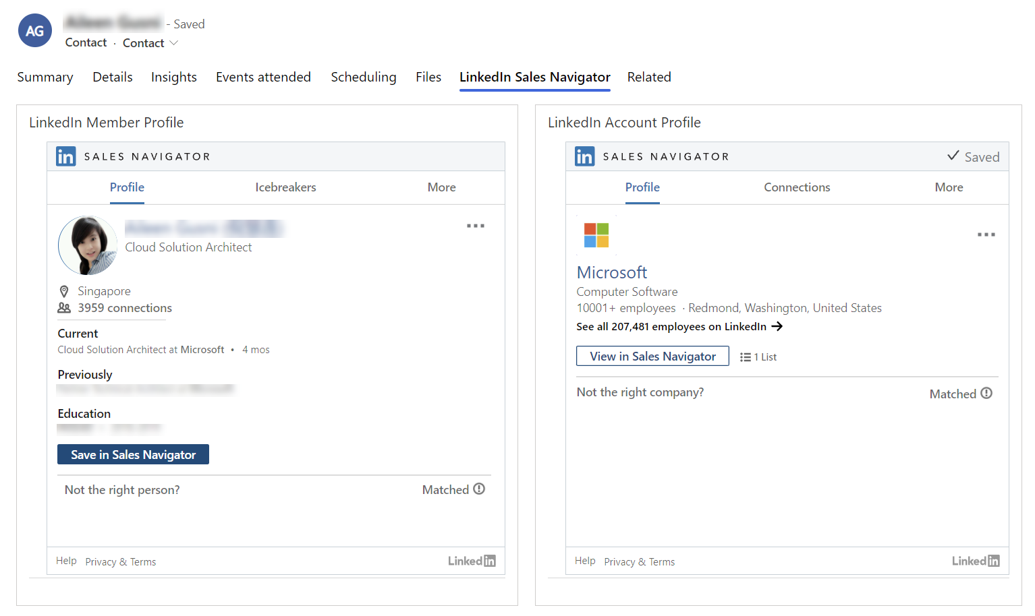

Now, you have installed, enabled, and explored some basic features of the LinkedIn Sales Navigator and Dynamics 365 Sales integration.

## Exercise 3: Sales Insights Add-in for Dynamics 365 Sales

In this exercise, you will learn how to enable and explore sales insight add-in for Dynamics 365 Sales.

Sales Insights continuously analyzes the vast collection of customer-interaction data already stored in your Dynamics 365 Sales and Microsoft 365 databases. This helps you to better understand your business relationships, evaluate your activities in relation to previous successes, and choose the best path forward. Also, it enables you to build strong relationships with customers, take actions based on insights, and close opportunities faster.

Sales Insights helps organizations in the following four areas:

* **Guided selling**: Guide sellers on their next course of action with timely and actionable insights.
* **Productivity intelligence**: Free up sellers' time by minimizing manual data entry with contextual, real-time suggestions for updating existing records and creating new records, making sure your data is always up to date.
* **Connection insights**: Build stronger relationships with customers and move relationships forward with AI-guided selling. Take preemptive steps to mitigate risks with a relationship health score.
* **Predictive models**: Increase conversion and win rates by using AI to prioritize leads and opportunities with the highest likelihood to convert and buy.

These Sales Insights features are categorized as [standard](https://docs.microsoft.com/en-us/dynamics365/ai/sales/overview?tabs=std1%2Cprim1" \l "standard-sales-insights-features) (Sales Enterprise plan) and [premium](https://docs.microsoft.com/en-us/dynamics365/ai/sales/overview?tabs=std1%2Cprim1" \l "premium-sales-insights-features) (Sales Premium license). The following diagram illustrates the various features available in Sales Insights:

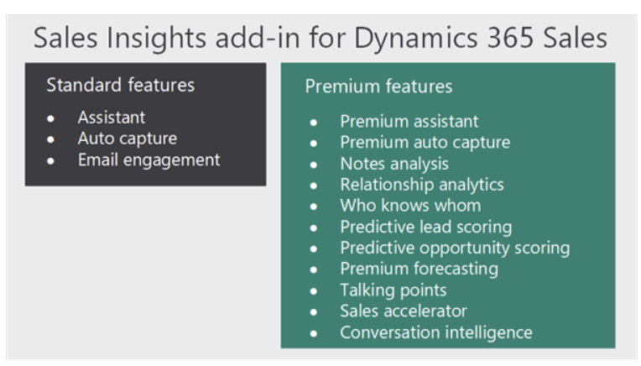

#### Pre-requisites: Start free trial of Sales Insight

1. Go to AppSource

<https://appsource.microsoft.com/en-us/product/dynamics-365/mscrm.70b76f06-f739-4808-bd58-b5674a0a42d4?tab=overview>

1. Sign in with the credential you use to access Dynamics 365

#### Task 1: Explore standard Sales Insight features

By default, the standard assistant is enabled.

1. Sign in to Dynamics 365 Sales, and go to the Sales Hub app.
2. Go to **Change area** in the lower-left corner of the page, and select **Sales Insights settings**.

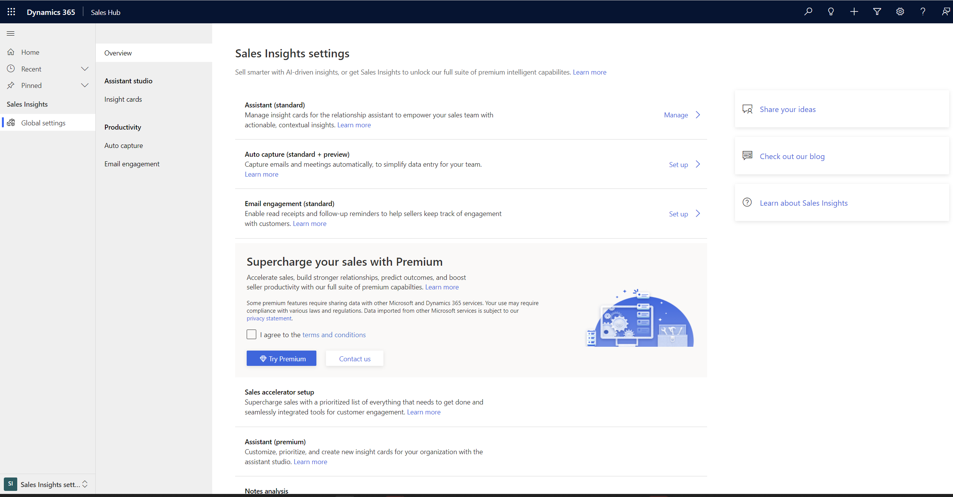

1. In the Insight Cards area, you can see available standard cards, which one are turned on and turned off

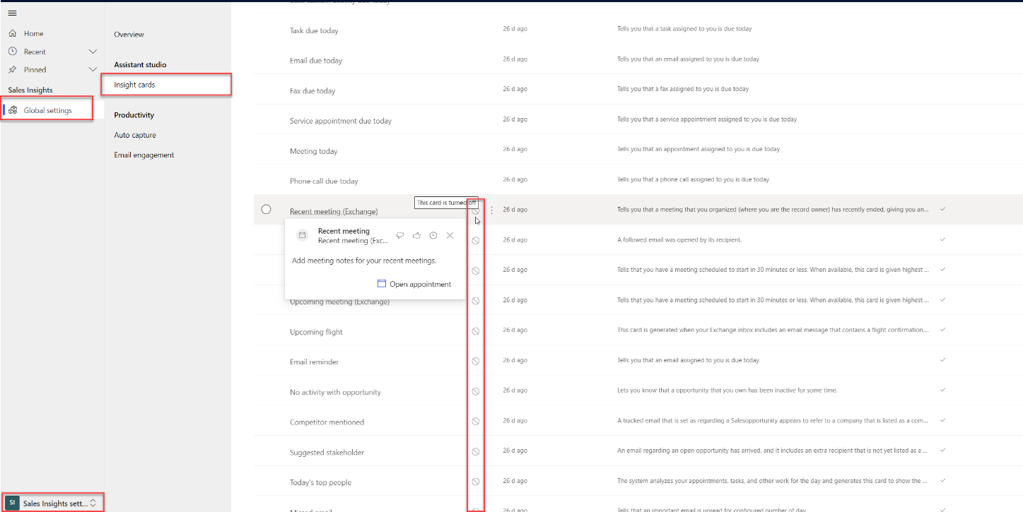

1. You can turn on the card that is turned off now

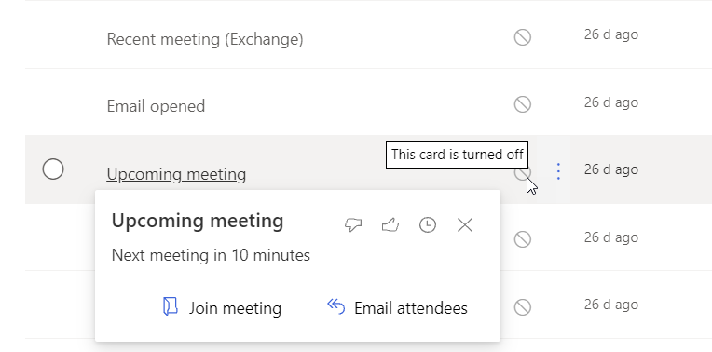

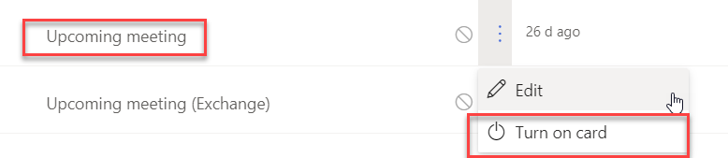

1. You can turn on as many as you want, for example:

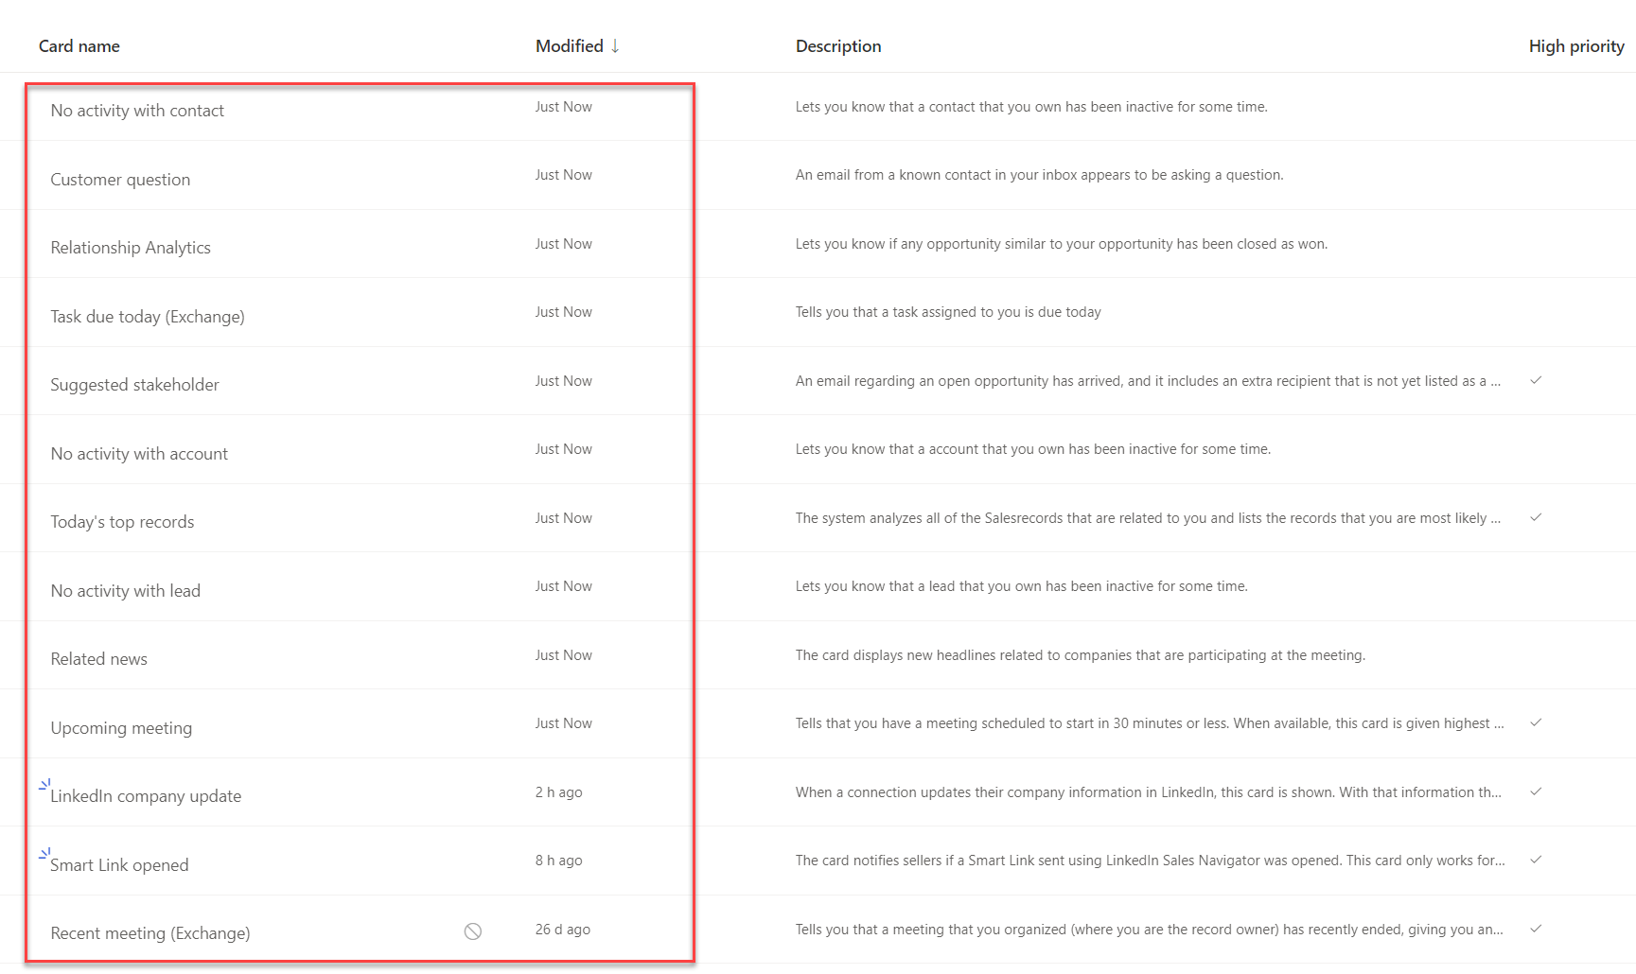

1. Now, go to **Dashboard** to view the result

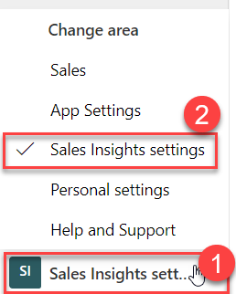

1. Here is one of the example of the assistant cards

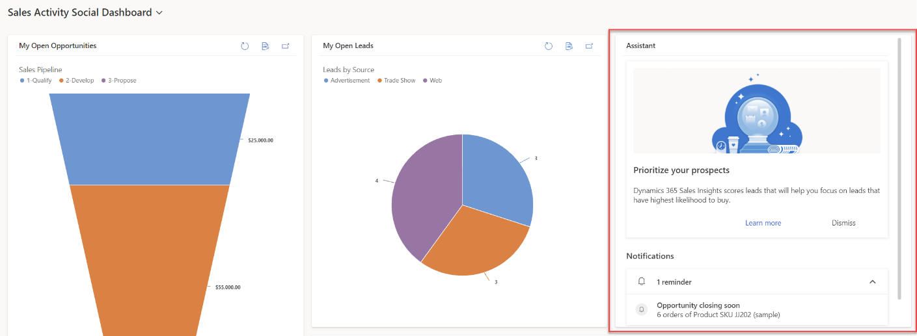

## Exercise 4: Sales Collaboration using Microsoft Teams Integration

If you're familiar with [Microsoft Teams](https://products.office.com/microsoft-teams/group-chat-software), you know it's the place to manage all your conversations, files, and tools in one team workspace. Create and edit documents right in the app and enjoy instant access to SharePoint, OneNote, Power BI, and now, customer engagement apps in Dynamics 365 (Dynamics 365 Sales, Dynamics 365 Customer Service, Dynamics 365 Field Service, Dynamics 365 Marketing, and Dynamics 365 Project Service Automation).

**Note:**

Microsoft Teams integration is not supported on the following:

* Dynamics 365 Customer Engagement (on-premises)
* Microsoft Dataverse environment
* Legacy web client or legacy apps
* If Dynamics 365 and Microsoft Teams are in different tenants

Dynamics 365 for Microsoft Teams integration enables users to easily work with customer information in customer engagement apps (such as Dynamics 365 Sales and Dynamics 365 Customer Service) and share files directly from Microsoft Teams. This helps them to be more productive and get work done more effectively.

* **Collaboration hub**: Access a shared workspace for Office apps that most of us already use to work sales opportunities.
* **File integration**: Co-author documents using Microsoft 365 and automatically sync with customer engagement apps in Dynamics 365. Files uploaded to a channel are available for the record that is pinned to the channel. Files are saved to Sharepoint are accessible in Microsoft Teams and in your customer engagement app. For more information: [Document management in Microsoft Teams integration](https://docs.microsoft.com/en-us/dynamics365/teams-integration/teams-doc-management)

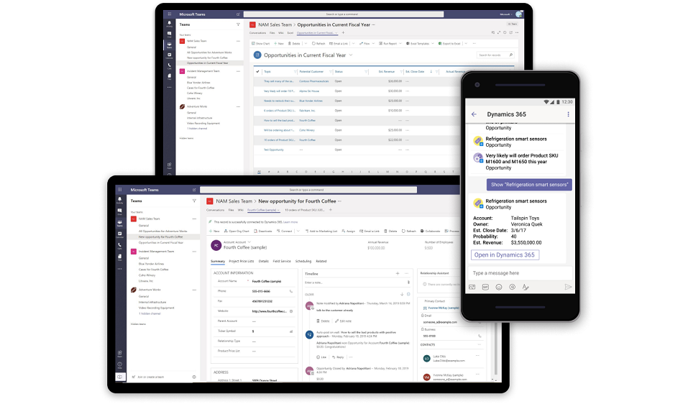

With the Dynamics 365 for Microsoft Teams integration, add app features that you rely on, to the Microsoft Teams app you collaborate with. This lets you easily work with your customer information and share files directly from Microsoft Teams.

* Access customer engagement app records by adding a Dynamics 365 tab into the Microsoft Teams channel. Collaborate at a large scale not only on a single app record (like a sales opportunity) but also on multiple records.
* Use Microsoft Teams integration to seamlessly collaborate on documents between customer engagement apps and Microsoft Teams.
* Collaborate on a set of records, such as active opportunity using Microsoft Teams conversation and easily access records on the go using the Dynamics 365 bot for Microsoft Teams mobile app.

#### Task 1: Install and Setup Microsoft Teams Integration

By default, the Basic and Enhanced Microsoft Teams integration is disabled for customer engagement apps in Dynamics 365

1. In the Sales Hub, the apps that you are in now (otherwise you need to go to Sales Hub first), go to App Settings

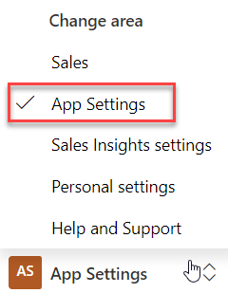

1. Under **Teams Chat and Channels**, select **Manage**.

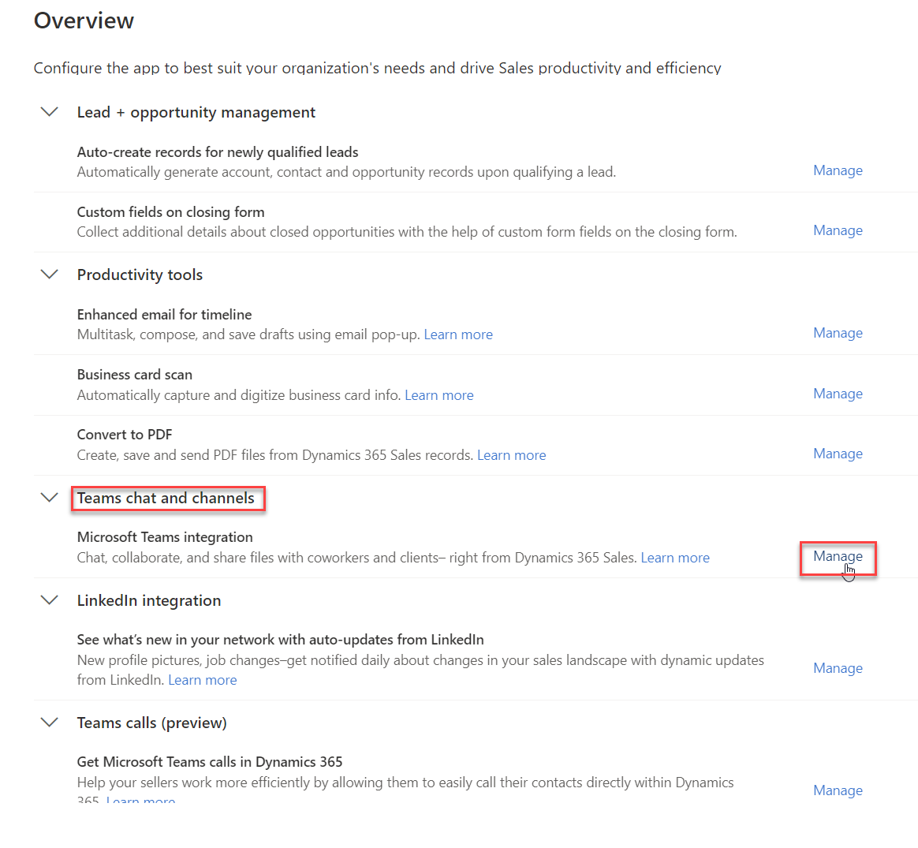

1. Turn on **Enable the linking of Dynamics 365 records to Microsoft Teams channels** to enable the [Basic Collaboration Experience](https://docs.microsoft.com/en-us/dynamics365/teams-integration/teams-collaboration). When Basic Microsoft Teams integration is enabled, the **Collaborate** button appears on customer engagement app records so you can see the connected team channel or set up a new connection in Microsoft Teams. In addition, in the **Documents** tab on the record page, the connected team channel file library will appear.’
2. To enable the [Enhanced Collaboration Experience](https://docs.microsoft.com/en-us/dynamics365/teams-integration/teams-collaboration-enhanced-experience), select **Yes** for **Enable Enhanced Microsoft Teams integration**. To turn on this option, you need Microsoft 365 tenant admin permissions. When Enhanced Microsoft Teams integration is enabled, the **Collaborate** button appears on the record and view page in customer engagement apps. You can set up a connection with any Microsoft Teams collaboration channel within an app.

On the consent dialog, select **Accept**.

**Important**

When you give your consent on behalf of your organization, the app gets full access to all Teams groups and associated content that the users have access to. Though the app has full access, it does not read or write to any of that data. The app just reads the teams/channels list or creates teams/channels for collaborating on Dynamics 365 data.

**Note**

If you don't select **Accept**, then when a user tries to pin an entity record or view to Microsoft Teams and shares the tab with another user, they'll receive the following error message: "The admin has not consented to use user sync feature, you can add them manually." If you receive this error message, see **[Error when you pin a record or view to teams channel](https://docs.microsoft.com/en-us/dynamics365/teams-integration/teams-troubleshoot" \l "error-when-you-pin-a-record-or-view-of-any-app-to-a-team-channel-if-your-user-role-permission-is-not-configured-correctly-by-your-customer-engagement-apps-system-admin)**.

1. You can also enable the Confidential Labels to create private teams for your sensitive contents

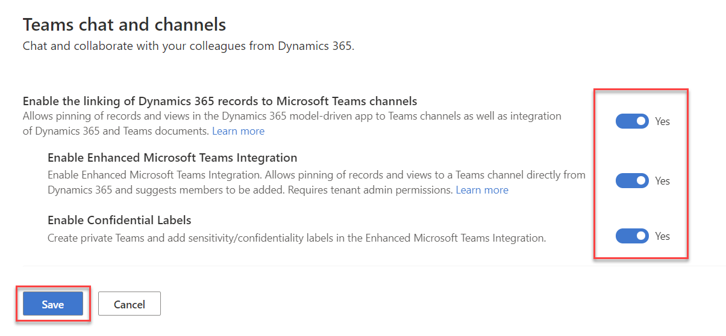

1. Save the changes. You should now be able to the see the **Collaborate** button when you open a record.
2. To test, you can open any Opportunity record

#### Task 2: Use Basic Collaboration experience for Microsoft Teams integration with customer engagement apps in Dynamics 365

Once installed, the Dynamics 365 app for Microsoft Teams enables collaborating with other team members by adding a customer engagement app in Dynamics 365 (Dynamics 365 Sales, Dynamics 365 Customer Service, Dynamics 365 Field Service, Dynamics 365 Marketing, or Dynamics 365 Project Service Automation) tab to a channel in Microsoft Teams.

**Connect an app record or view to a team channel**

From a team channel, you can connect a customer engagement app (such as Dynamics 365 Sales or Dynamics 365 Customer Service) record or view to collaborate on any entity, such as customer accounts, opportunities, and more. You can use the Web version: <https://teams.microsoft.com>

1. Open a team channel, and select the **Add** button ().

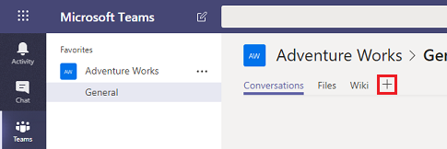

1. Select the **Dynamics 365** icon to pin an app record to a channel and select **Add**

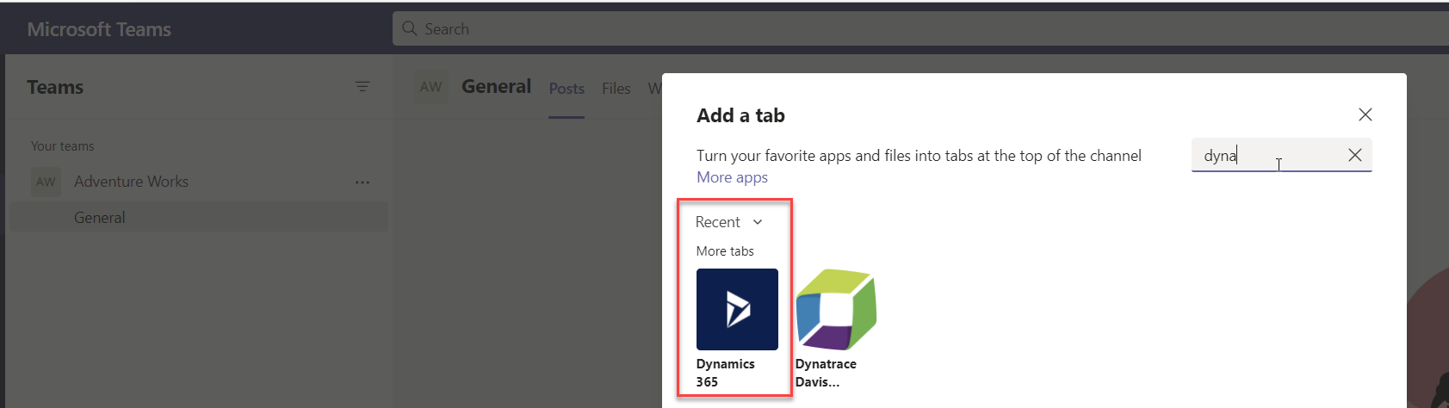

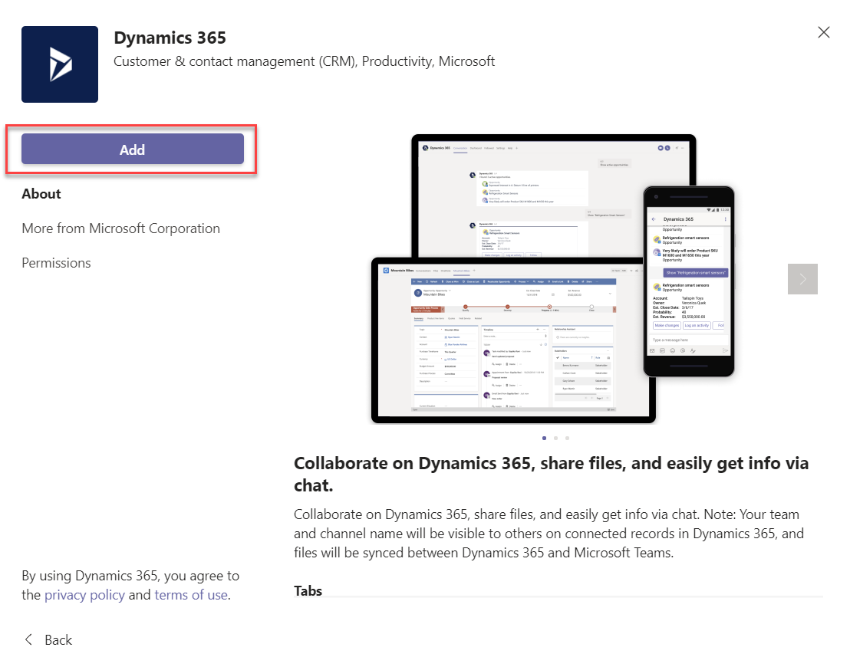

1. Choose your environment and which app you want to connect to.

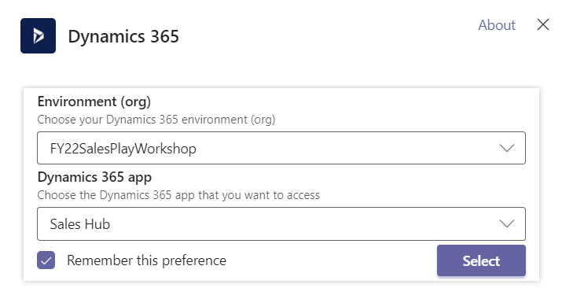

1. Select **Entity Selection**, or **View Selection**.

**Entity Selection**

Search for an entity to connect. You can pick a recently viewed record or use search to find records. You can use **Filter by** to narrow the search to an entity type.

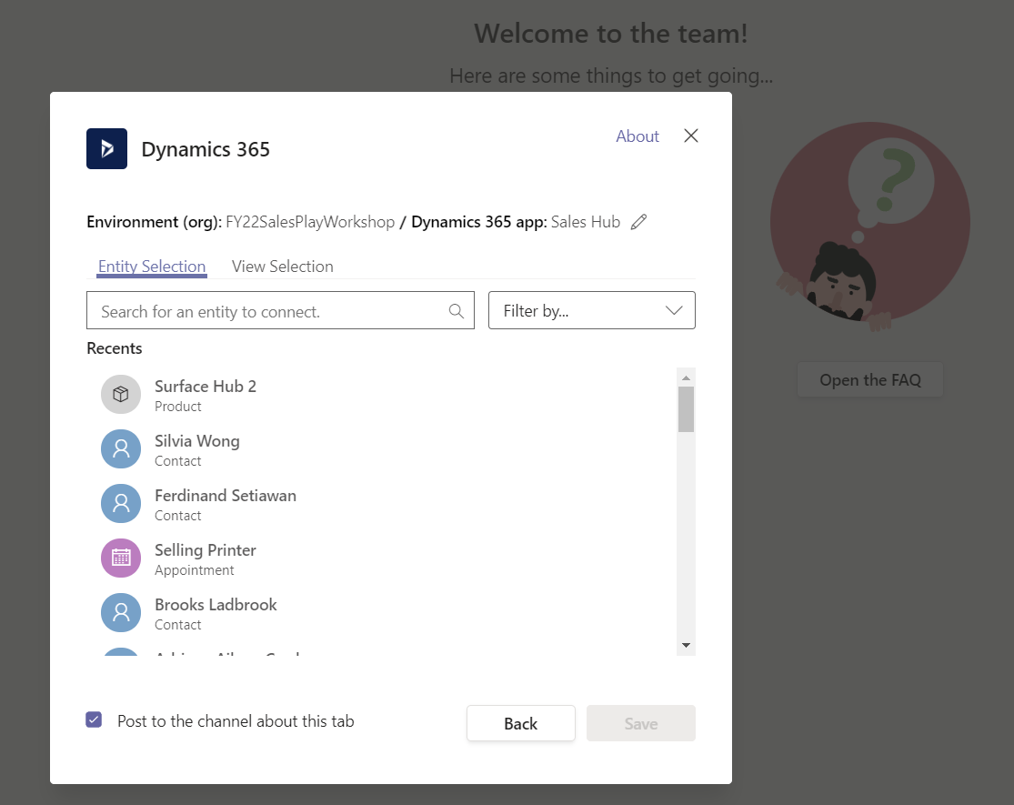

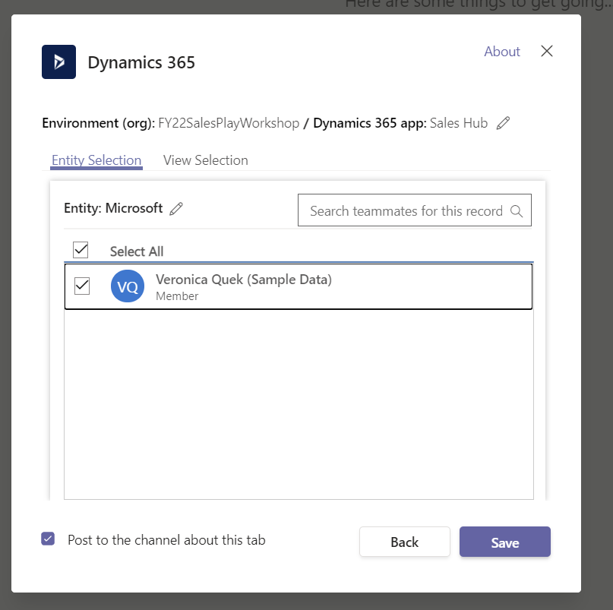

If you are the owner of the team, you will see an option to add other members to the team who either owns the record, or it has been shared with them. When you are done, select **Save**.

**Note:**

The Enhanced Collaboration Experience needs to be enabled to add members to the team. For more information, see **[Install and set up the Dynamics 365 app for Microsoft Teams](https://docs.microsoft.com/en-us/dynamics365/teams-integration/teams-install-app)**.

* Once you complete the above steps, you'll see a notification of a successful connection and the app record will load in the new added tab. You can interact with the record as if you were using the app. Those with **Write** permissions can edit the record. Changes will be synchronized with the customer engagement app in Dynamics 365.

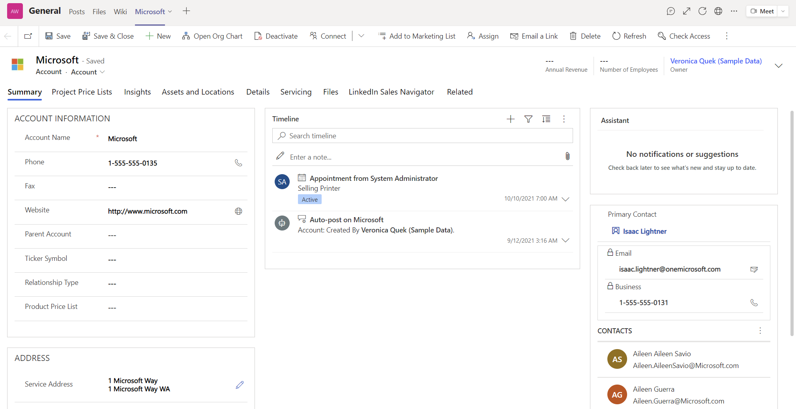

**View Selection**

Select an entity to see the list of active views that are available for the entity in the app and then select **Save**.

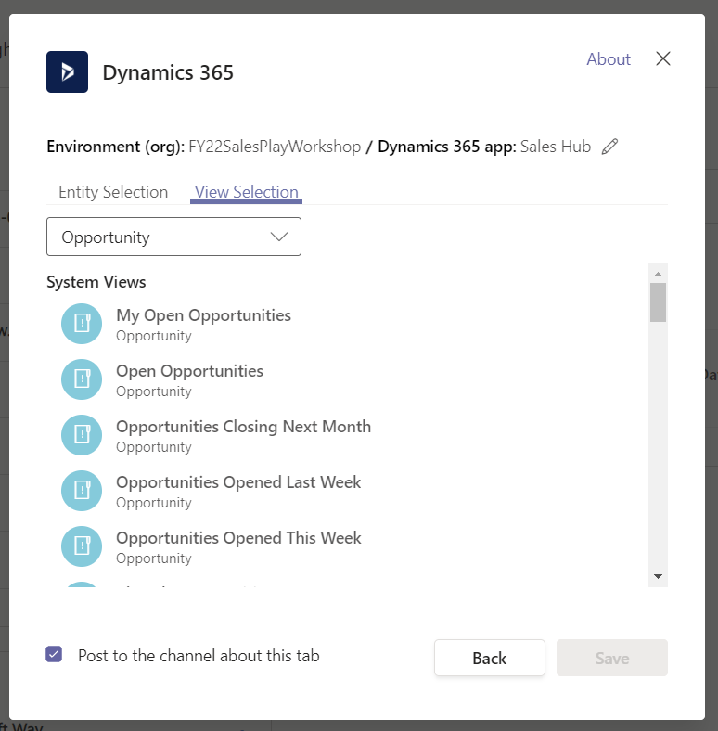

Once you complete the above steps, you'll see the app entity view in the new added tab.

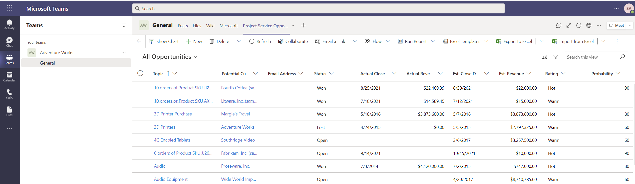

**Note**

If you select a personal view (**My Views**) instead of **System Views**, it’s recommended that you share the view with other users in Microsoft Teams before you add the view to the Microsoft Teams channel. Otherwise, other team members will not hae access to the view content.

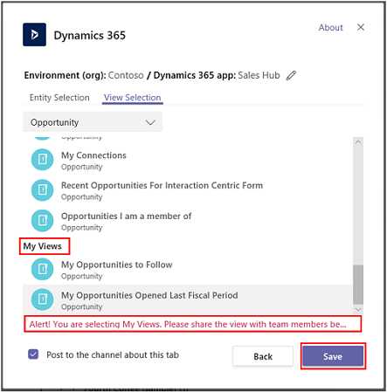

1. If you have multiple environments or app modules, you can change the environment and app module by selecting **Edit** () to specify which environment or app module to use in Microsoft Teams.

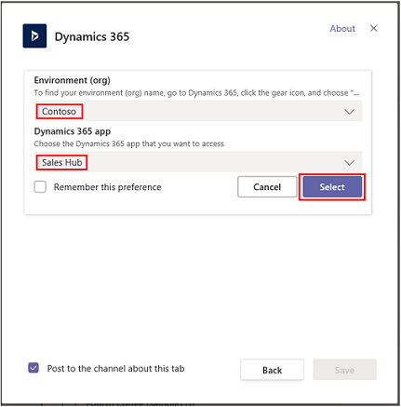

Select **Remember this preference** to set the environment and app selections to be the default personal dashboard that appears when you select **My Dashboard**.

To access these setting again, select the **Settings** tab.

Once the app tab is set up in Microsoft Teams collaboration channel, you can start working with your team members on the pinned app customer information and share files directly from Microsoft Teams.

**Have a conversation**

You can chat with your team members side-by-side with the app tab. From the app tab pinned in a Microsoft Teams channel, select the **Show tab conversation** button to open the conversation tab.

**Open an app record or view**

It's easy to navigate to the pinned app record or view page from Microsoft Teams. From the app record tab pinned in a Microsoft Teams channel, select the **Go to website** button to open the record or view page in Dynamics 365 apps.

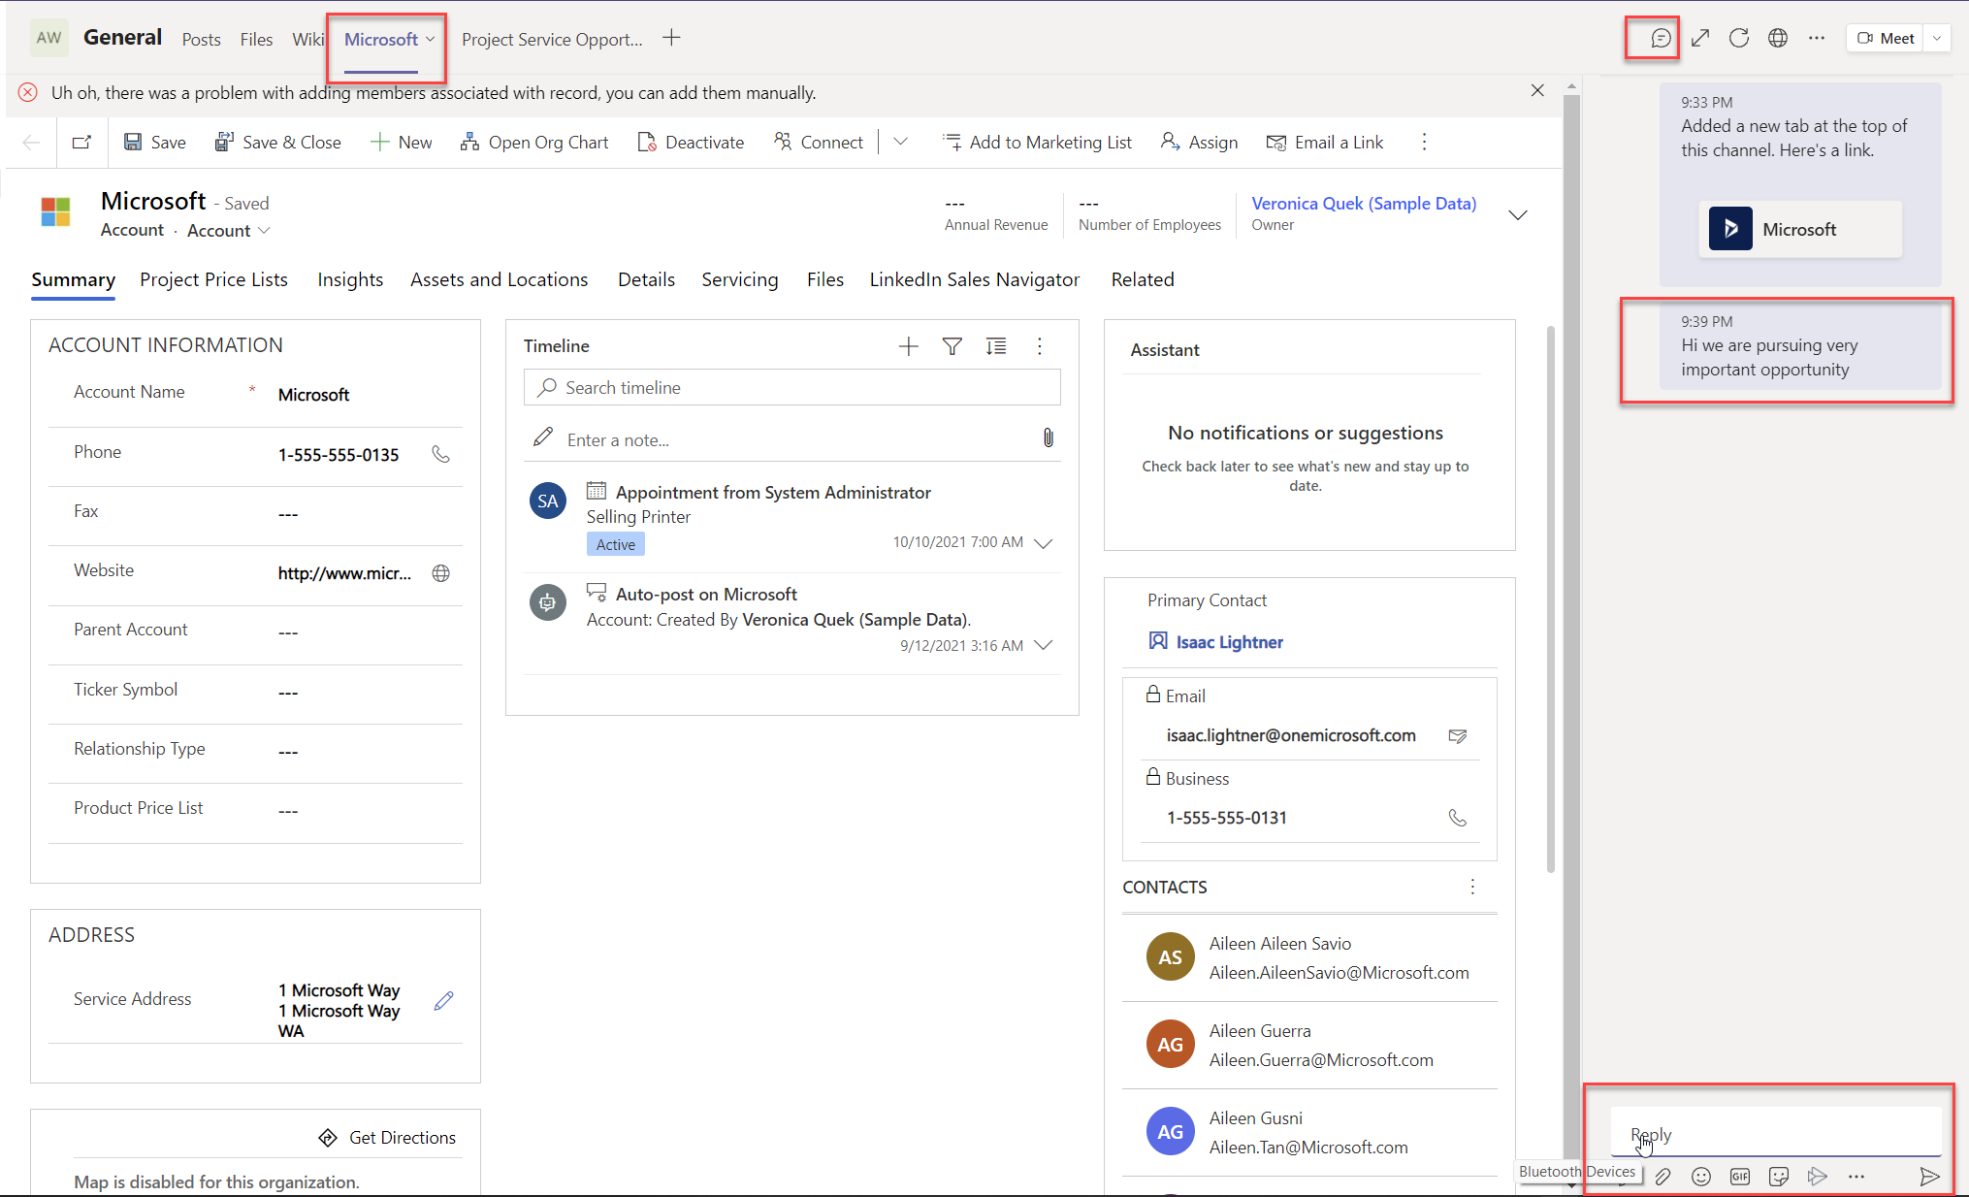

#### Task 3: View and associate files

Select the **Files** tab in the connected team channel to associate files with an app record. Files added here will appear in apps in Dynamics 365 under **Documents** for the linked record. Likewise, when you add a document to an app record, that document will appear in Microsoft Teams under the **Files** tab.

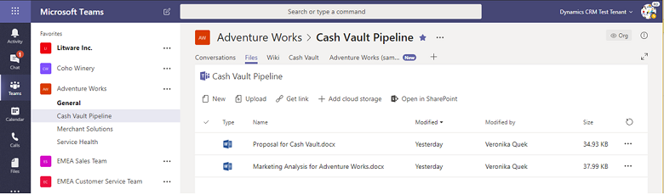

If you see this message: Shared files exist in multiple locations. Select "Document Location" to see files in other locations.

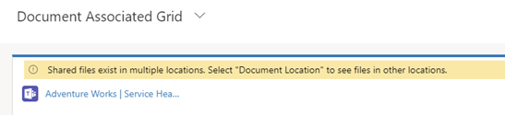

When there is more than one Microsoft Teams channel connected to an app record, each of the channels appears as a separate document location in the customer engagement app. You can switch to a different location by selecting **Document Location** to specify the location of the file.

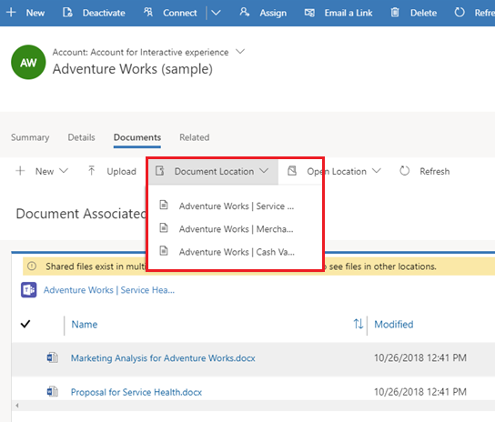

To view a consolidated file list across all document locations including all connected team channel file libraries, from **Document Location** select **All Locations**.

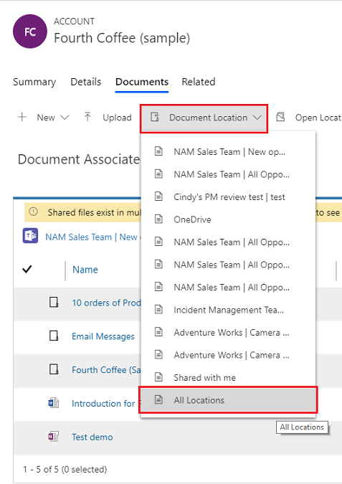

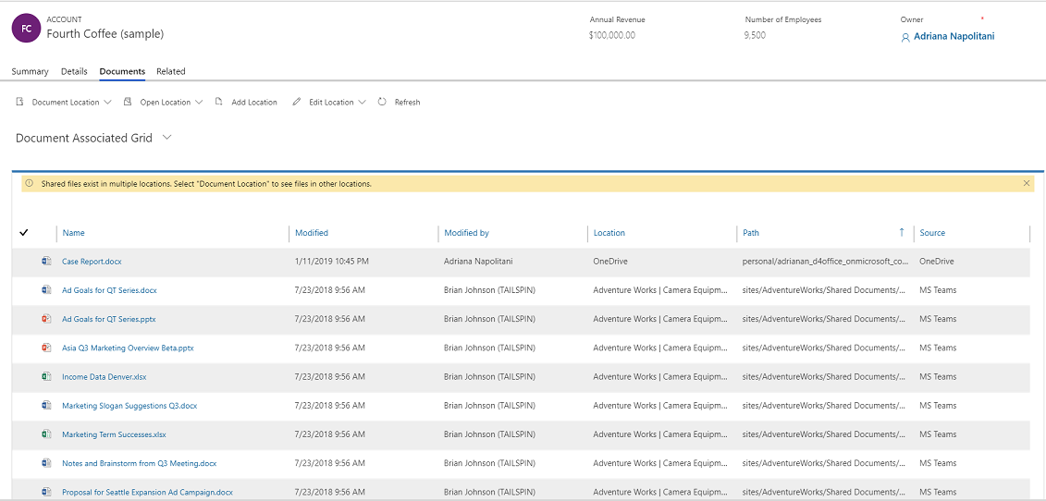

#### Task 4: Collaboration experience in an app

In a customer engagement app in Dynamics 365 (such as Dynamics 365 Sales and Dynamics 365 Customer Service), you can see the connected Microsoft Teams channel and files from the Microsoft Teams channel.

For more information on which entities support the collaborate option, see [Record types that support Microsoft Teams integration](https://docs.microsoft.com/en-us/dynamics365/teams-integration/teams-collaboration" \l "record-types-that-support-microsoft-teams-integration).

On an app record page, select **Collaborate** to display a list of all the connected team channels. Then, select a team channel to go to the relevant channel conversation in Microsoft Teams.

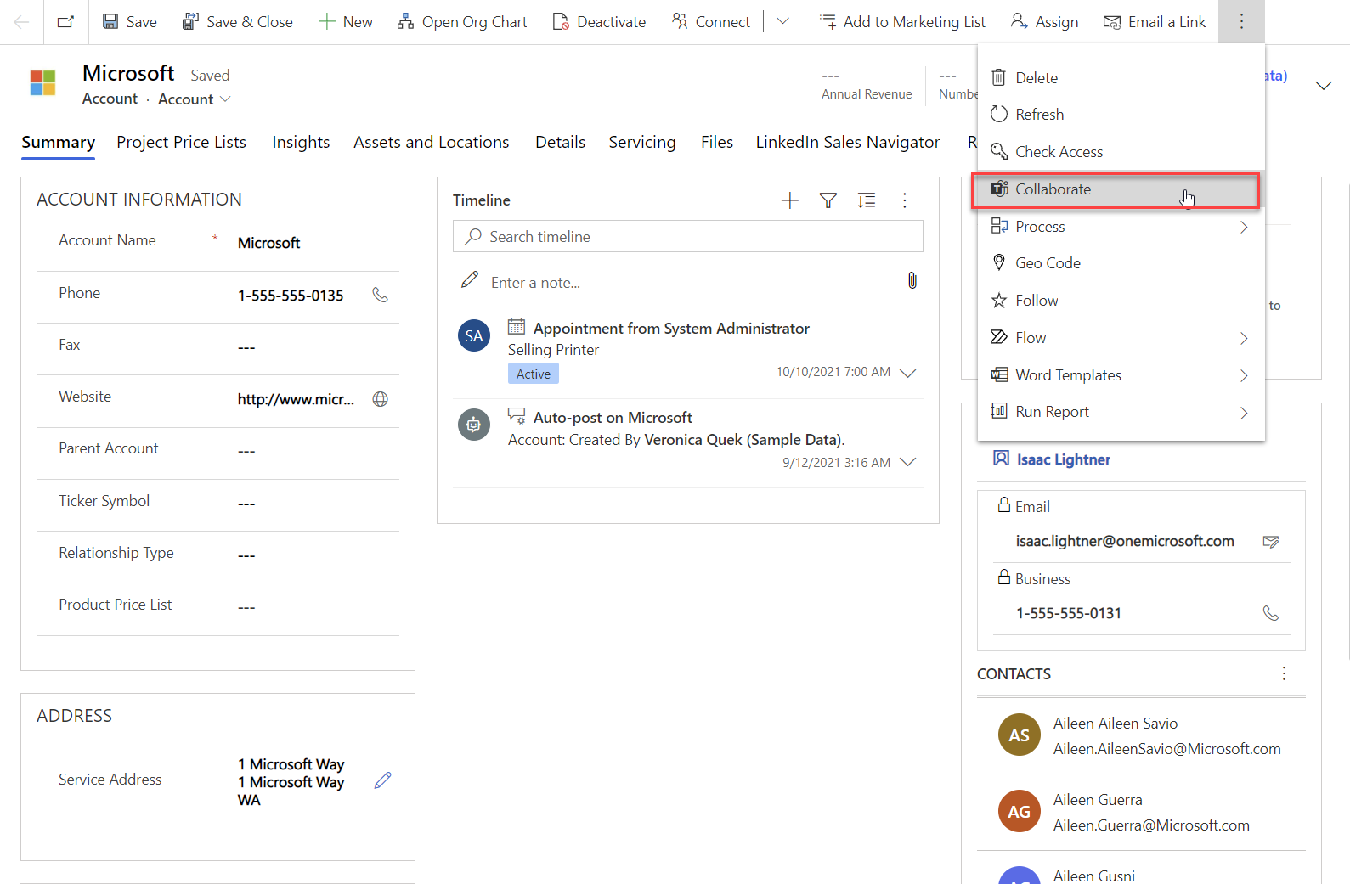

In addition, document management in customer engagement apps in Dynamics 365 is integrated with Microsoft Teams. You can see the connected channel file library in the app and directly upload files; uploaded files will appear in the connected team channel file library under the **Files** tab in Microsoft Teams. Files uploaded in the Microsoft Teams connected channel will appear in the **Documents** tab in your app.

Reference: <https://docs.microsoft.com/en-us/dynamics365/teams-integration/teams-collaboration>

# Copyright

© 2021 Microsoft Corporation. All rights reserved.

By using this demo/lab, you agree to the following terms:

The technology/functionality described in this demo/lab is provided by Microsoft Corporation for purposes of obtaining your feedback and to provide you with a learning experience. You may only use the demo/lab to evaluate such technology features and functionality and provide feedback to Microsoft. You may not use it for any other purpose. You may not modify, copy, distribute, transmit, display, perform, reproduce, publish, license, create derivative works from, transfer, or sell this demo/lab or any portion thereof.

COPYING OR REPRODUCTION OF THE DEMO/LAB (OR ANY PORTION OF IT) TO ANY OTHER SERVER OR LOCATION FOR FURTHER REPRODUCTION OR REDISTRIBUTION IS EXPRESSLY PROHIBITED.

THIS DEMO/LAB PROVIDES CERTAIN SOFTWARE TECHNOLOGY/PRODUCT FEATURES AND FUNCTIONALITY, INCLUDING POTENTIAL NEW FEATURES AND CONCEPTS, IN A SIMULATED ENVIRONMENT WITHOUT COMPLEX SET-UP OR INSTALLATION FOR THE PURPOSE DESCRIBED ABOVE. THE TECHNOLOGY/CONCEPTS REPRESENTED IN THIS DEMO/LAB MAY NOT REPRESENT FULL FEATURE FUNCTIONALITY AND MAY NOT WORK THE WAY A FINAL VERSION MAY WORK. WE ALSO MAY NOT RELEASE A FINAL VERSION OF SUCH FEATURES OR CONCEPTS. YOUR EXPERIENCE WITH USING SUCH FEATURES AND FUNCTIONALITY IN A PHYSICAL ENVIRONMENT MAY ALSO BE DIFFERENT.

**FEEDBACK**. If you give feedback about the technology features, functionality and/or concepts described in this demo/lab to Microsoft, you give to Microsoft, without charge, the right to use, share and commercialize your feedback in any way and for any purpose. You also give to third parties, without charge, any patent rights needed for their products, technologies and services to use or interface with any specific parts of a Microsoft software or service that includes the feedback. You will not give feedback that is subject to a license that requires Microsoft to license its software or documentation to third parties because we include your feedback in them. These rights survive this agreement.

MICROSOFT CORPORATION HEREBY DISCLAIMS ALL WARRANTIES AND CONDITIONS WITH REGARD TO THE DEMO/LAB, INCLUDING ALL WARRANTIES AND CONDITIONS OF MERCHANTABILITY, WHETHER EXPRESS, IMPLIED OR STATUTORY, FITNESS FOR A PARTICULAR PURPOSE, TITLE AND NON-INFRINGEMENT. MICROSOFT DOES NOT MAKE ANY ASSURANCES OR REPRESENTATIONS WITH REGARD TO THE ACCURACY OF THE RESULTS, OUTPUT THAT DERIVES FROM USE OF DEMO/ LAB, OR SUITABILITY OF THE INFORMATION CONTAINED IN THE DEMO/LAB FOR ANY PURPOSE.

**DISCLAIMER**

This demo/lab contains only a portion of new features and enhancements in Microsoft Power Apps. Some of the features might change in future releases of the product. In this demo/lab, you will learn about some, but not all, new features.